UNITED STATES
SECURITIES AND EXCHANGE COMMISSION
WASHINGTON, D.C. 20549

FORM 8-K

CURRENT REPORT
Pursuant to Section 13 or 15(d) of the Securities Exchange Act of 1934
Date of Report (Date of earliest event reported): September 08, 2026

ODYSSEY THERAPEUTICS, INC.
(Exact name of Registrant as Specified in Its Charter)

Delaware |  |  | 001-43270 | 86-3384382
(State or Other Jurisdiction  of Incorporation) |  |  | (Commission File Number) | (IRS Employer  Identification No.)
51 Sleeper Street, Suite 800
Boston, Massachusetts |  |  |  | 02210
(Address of Principal Executive Offices) |  |  |  | (Zip Code)

Registrant’s Telephone Number, Including Area Code: (617) 865-9628

(Former Name or Former Address, if Changed Since Last Report)

Check the appropriate box below if the Form 8-K filing is intended to simultaneously satisfy the filing obligation of the registrant under any of the following provisions:
☐Written communications pursuant to Rule 425 under the Securities Act (17 CFR 230.425)
☐Soliciting material pursuant to Rule 14a-12 under the Exchange Act (17 CFR 240.14a-12)
☐Pre-commencement communications pursuant to Rule 14d-2(b) under the Exchange Act (17 CFR 240.14d-2(b))
☐Pre-commencement communications pursuant to Rule 13e-4(c) under the Exchange Act (17 CFR 240.13e-4(c))
Securities registered pursuant to Section 12(b) of the Act:
Title of each class |  | Trading  Symbol(s) |  | Name of each exchange on which registered
Common Stock, par value $0.001 per share |  | ODTX |  | The Nasdaq Stock Market
Indicate by check mark whether the registrant is an emerging growth company as defined in Rule 405 of the Securities Act of 1933 (§ 230.405 of this chapter) or Rule 12b-2 of the Securities Exchange Act of 1934 (§ 240.12b-2 of this chapter).
Emerging growth company ☒
If an emerging growth company, indicate by check mark if the registrant has elected not to use the extended transition period for complying with any new or revised financial accounting standards provided pursuant to Section 13(a) of the Exchange Act. ☐

Item 7.01 Regulation FD Disclosure.
On September 8, 2026, Odyssey Therapeutics, Inc. (the “Company”) posted a corporate presentation on its website at https://investors.odysseytx.com/news-events/presentations. A copy of the presentation is furnished herewith as Exhibit 99.1 to this Current Report on Form 8-K. The information contained in Item 7.01 of this Current Report on Form 8-K and Exhibit 99.1 attached hereto is intended to be furnished and shall not be deemed “filed” for purposes of Section 18 of the Exchange Act, or otherwise subject to the liabilities of that section, nor shall it be deemed incorporated by reference in any filing under the Securities Act or the Exchange Act, except as expressly set forth by specific reference in such a filing. The furnishing of this information hereby shall not be deemed an admission as to the materiality of any such information.

Item 9.01 Financial Statements and Exhibits.
Exhibit  Number |  | Description
99.1 |  | Corporate Presentation, dated September 2026
104 |  | Cover Page Interactive Data File (embedded within the Inline XBRL document)

SIGNATURES
Pursuant to the requirements of the Securities Exchange Act of 1934, the registrant has duly caused this report to be signed on its behalf by the undersigned hereunto duly authorized.
 |  |  | Odyssey Therapeutics, Inc.
Date: | September 8, 2026 | By: | /s/ Jason Haas
Jason Haas
Chief Financial Officer


Corporate ?Presentation September 2026

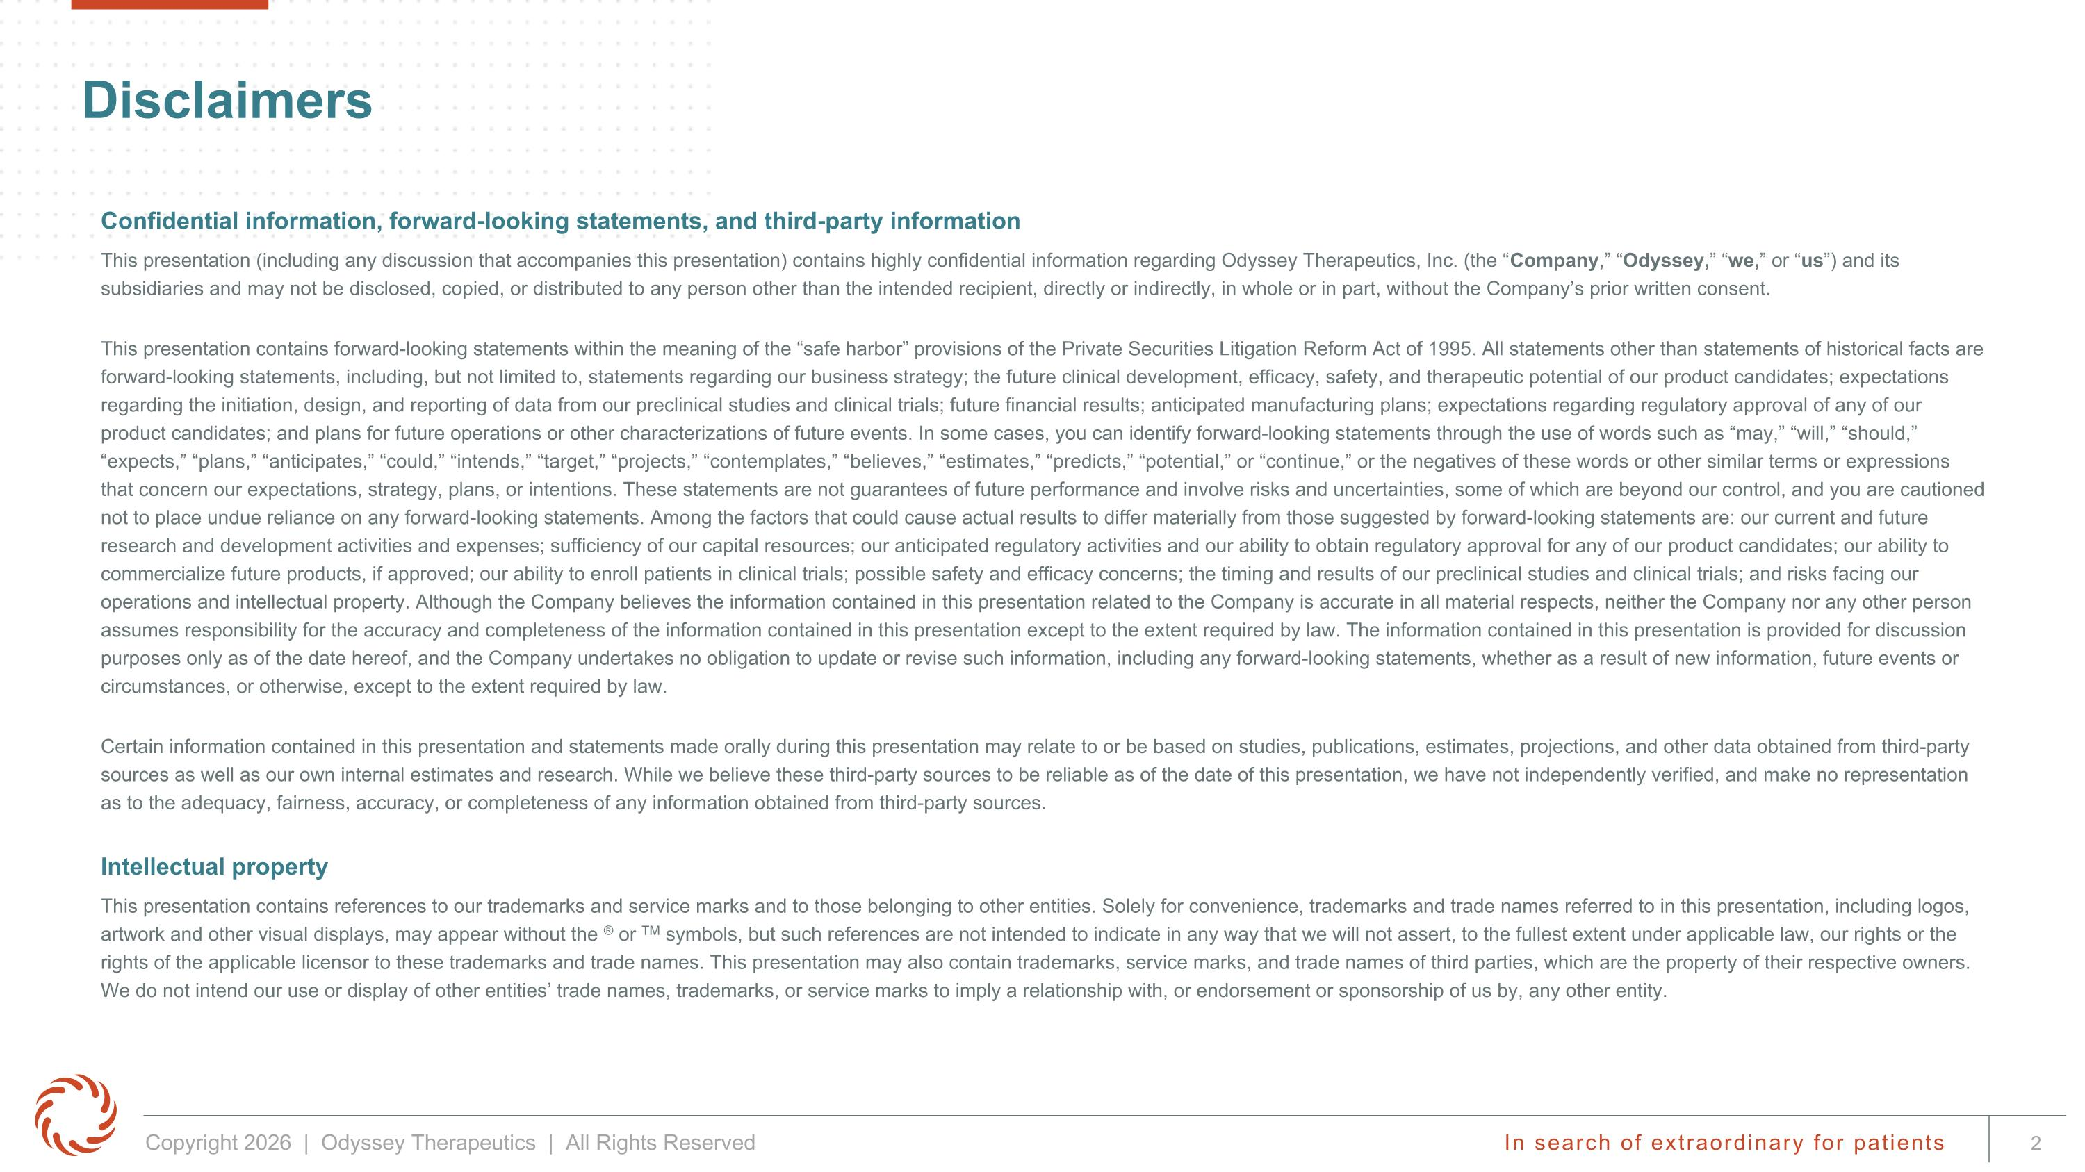
Confidential information, forward-looking statements, and third-party information This presentation (including any discussion that accompanies this presentation) contains highly confidential information regarding Odyssey Therapeutics, Inc. (the “Company,” “Odyssey,” “we,” or “us”) and its subsidiaries and may not be disclosed, copied, or distributed to any person other than the intended recipient, directly or indirectly, in whole or in part, without the Company’s prior written consent. This presentation contains forward-looking statements within the meaning of the “safe harbor” provisions of the Private Securities Litigation Reform Act of 1995. All statements other than statements of historical facts are forward-looking statements, including, but not limited to, statements regarding our business strategy; the future clinical development, efficacy, safety, and therapeutic potential of our product candidates; expectations regarding the initiation, design, and reporting of data from our preclinical studies and clinical trials; future financial results; anticipated manufacturing plans; expectations regarding regulatory approval of any of our product candidates; and plans for future operations or other characterizations of future events. In some cases, you can identify forward-looking statements through the use of words such as “may,” “will,” “should,” “expects,” “plans,” “anticipates,” “could,” “intends,” “target,” “projects,” “contemplates,” “believes,” “estimates,” “predicts,” “potential,” or “continue,” or the negatives of these words or other similar terms or expressions that concern our expectations, strategy, plans, or intentions. These statements are not guarantees of future performance and involve risks and uncertainties, some of which are beyond our control, and you are cautioned not to place undue reliance on any forward-looking statements. Among the factors that could cause actual results to differ materially from those suggested by forward-looking statements are: our current and future research and development activities and expenses; sufficiency of our capital resources; our anticipated regulatory activities and our ability to obtain regulatory approval for any of our product candidates; our ability to commercialize future products, if approved; our ability to enroll patients in clinical trials; possible safety and efficacy concerns; the timing and results of our preclinical studies and clinical trials; and risks facing our operations and intellectual property. Although the Company believes the information contained in this presentation related to the Company is accurate in all material respects, neither the Company nor any other person assumes responsibility for the accuracy and completeness of the information contained in this presentation except to the extent required by law. The information contained in this presentation is provided for discussion purposes only as of the date hereof, and the Company undertakes no obligation to update or revise such information, including any forward-looking statements, whether as a result of new information, future events or circumstances, or otherwise, except to the extent required by law. Certain information contained in this presentation and statements made orally during this presentation may relate to or be based on studies, publications, estimates, projections, and other data obtained from third-party sources as well as our own internal estimates and research. While we believe these third-party sources to be reliable as of the date of this presentation, we have not independently verified, and make no representation as to the adequacy, fairness, accuracy, or completeness of any information obtained from third-party sources. Intellectual property This presentation contains references to our trademarks and service marks and to those belonging to other entities. Solely for convenience, trademarks and trade names referred to in this presentation, including logos, artwork and other visual displays, may appear without the ® or TM symbols, but such references are not intended to indicate in any way that we will not assert, to the fullest extent under applicable law, our rights or the rights of the applicable licensor to these trademarks and trade names. This presentation may also contain trademarks, service marks, and trade names of third parties, which are the property of their respective owners. We do not intend our use or display of other entities’ trade names, trademarks, or service marks to imply a relationship with, or endorsement or sponsorship of us by, any other entity. Disclaimers

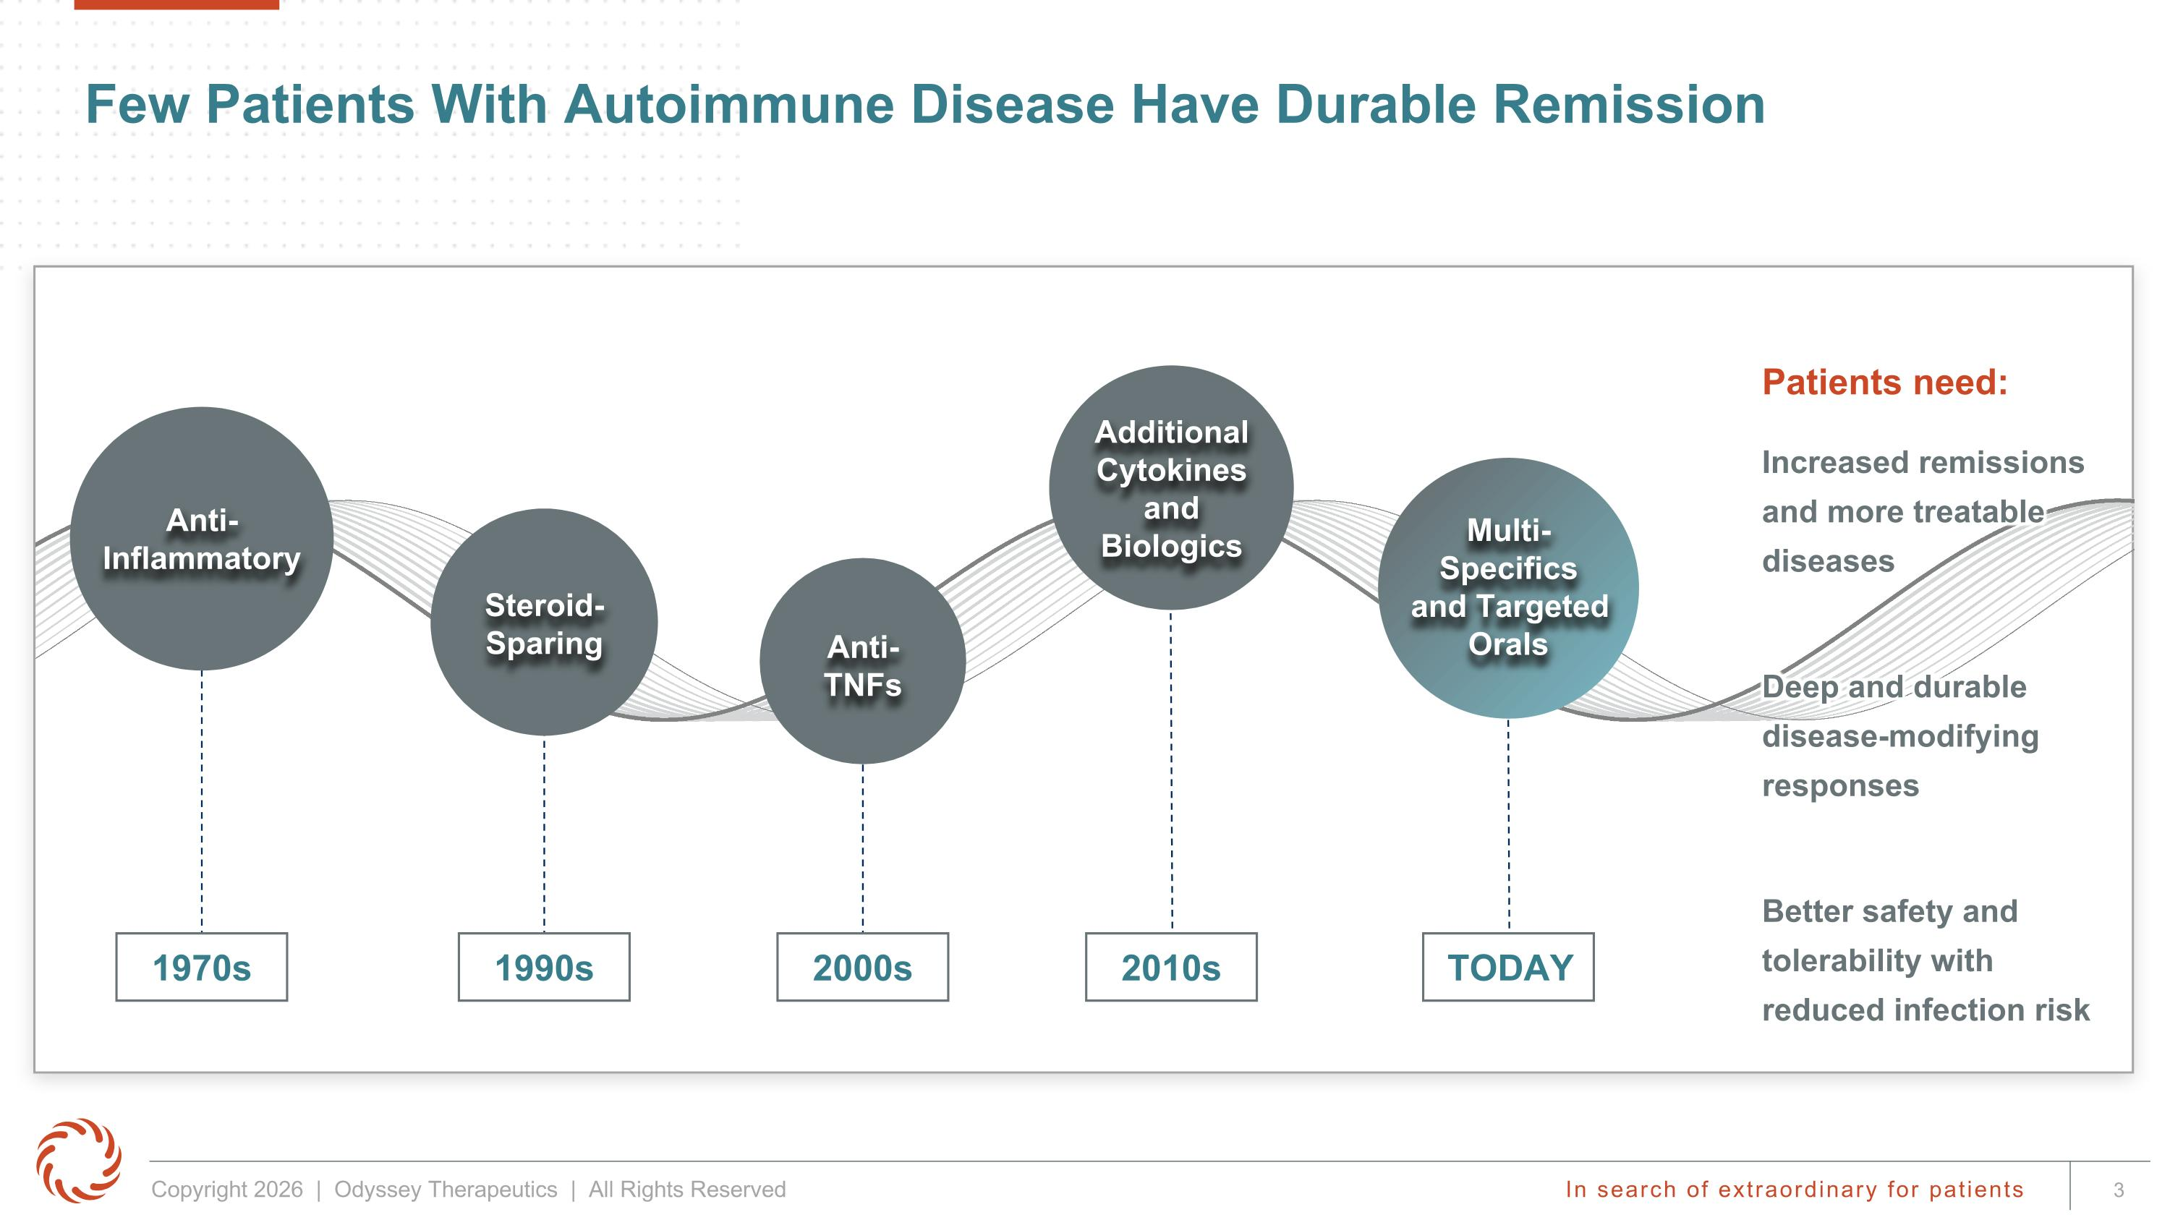
Few Patients With Autoimmune Disease Have Durable Remission Patients need: Increased remissions and more treatable diseases Deep and durable disease-modifying responses Better safety and tolerability with reduced infection risk Anti-Inflammatory 1970s Steroid-Sparing 1990s Anti-TNFs 2000s Additional Cytokines and Biologics 2010s Multi-Specifics ?and Targeted Orals TODAY

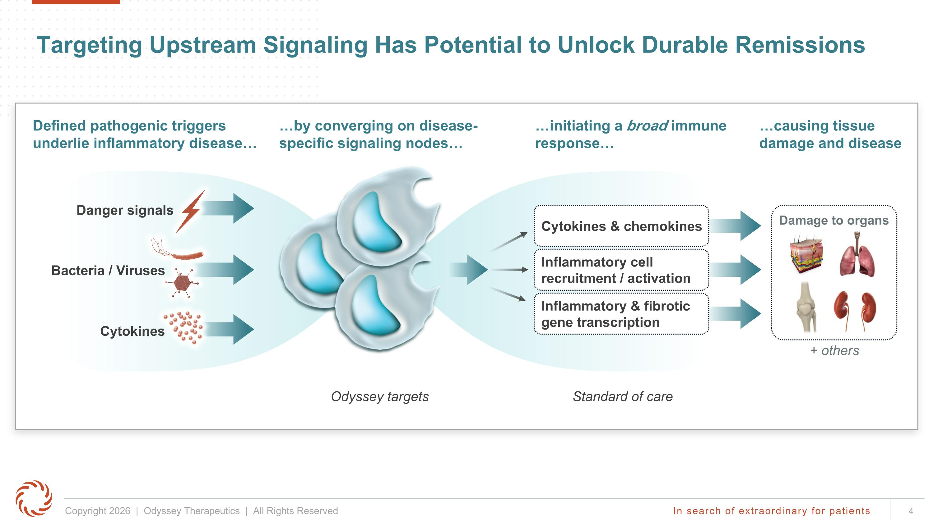
Targeting Upstream Signaling Has Potential to Unlock Durable Remissions Defined pathogenic triggers underlie inflammatory disease by converging on disease-specific signaling nodes initiating a broad immune response causing tissue damage and disease Cytokines & chemokines Inflammatory cell ?recruitment / activation Inflammatory & fibrotic ?gene transcription Odyssey targets Bacteria / Viruses Danger signals Cytokines Damage to organs + others Standard of care

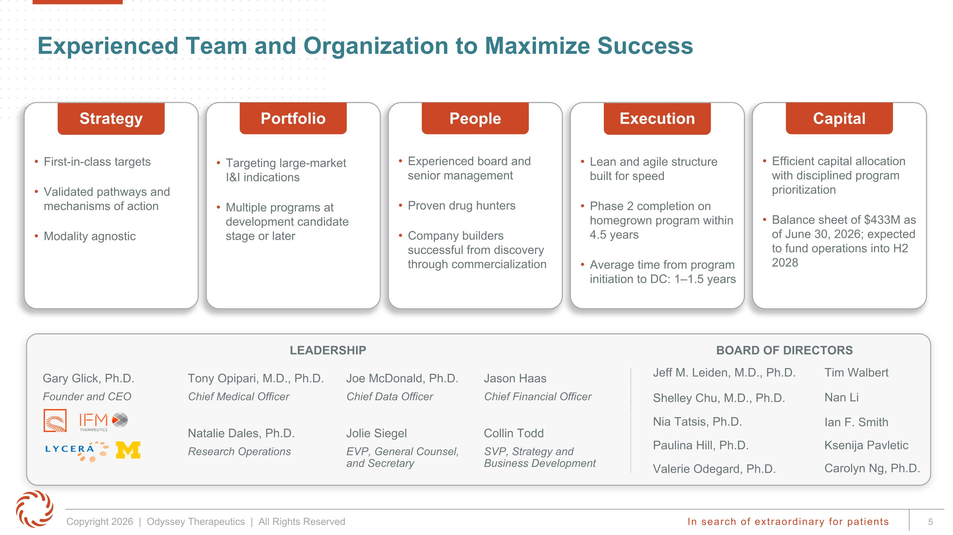
BOARD OF DIRECTORS Experienced Team and Organization to Maximize Success Gary Glick, Ph.D. Founder and CEO Tony Opipari, M.D., Ph.D. Chief Medical Officer Joe McDonald, Ph.D. Chief Data Officer Jason Haas Chief Financial Officer Valerie Odegard, Ph.D. Tim Walbert Nia Tatsis, Ph.D. Jeff M. Leiden, M.D., Ph.D. Ian F. Smith LEADERSHIP First-in-class targets Validated pathways and mechanisms of action Modality agnostic Strategy Experienced board and senior management Proven drug hunters Company builders successful from discovery through commercialization People Targeting large-market ?I&I indications Multiple programs at development candidate stage or later Portfolio Lean and agile structure built for speed Phase 2 completion on homegrown program within 4.5 years Average time from program initiation to DC: 1–1.5 years Execution Efficient capital allocation with disciplined program prioritization Balance sheet of $433M as of June 30, 2026; expected to fund operations into H2 2028 Capital Nan Li Paulina Hill, Ph.D. Ksenija Pavletic Shelley Chu, M.D., Ph.D. Carolyn Ng, Ph.D. Natalie Dales, Ph.D. Research Operations Jolie Siegel EVP, General Counsel, and Secretary Collin Todd SVP, Strategy and Business Development

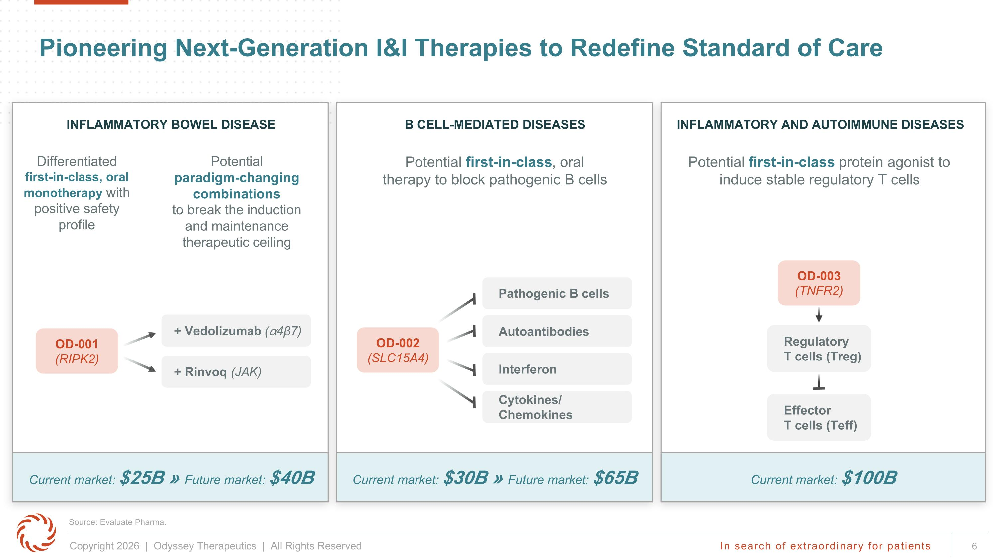
Pioneering Next-Generation I&I Therapies to Redefine Standard of Care Current market: $100B INFLAMMATORY BOWEL DISEASE B CELL-MEDIATED DISEASES INFLAMMATORY AND AUTOIMMUNE DISEASES Differentiated ?first-in-class, oral monotherapy with positive safety profile Potential first-in-class, oral therapy to block pathogenic B cells Potential first-in-class protein agonist to induce stable regulatory T cells Potential paradigm-changing combinations?to break the induction and maintenance therapeutic ceiling OD-001 (RIPK2) + Vedolizumab (⍺4β7) + Rinvoq (JAK) OD-002 (SLC15A4) Pathogenic B cells Autoantibodies Interferon Cytokines/?Chemokines Current market: $30B » Future market: $65B Current market: $25B » Future market: $40B OD-003 (TNFR2) Regulatory ?T cells (Treg) Effector ?T cells (Teff) Source: Evaluate Pharma.

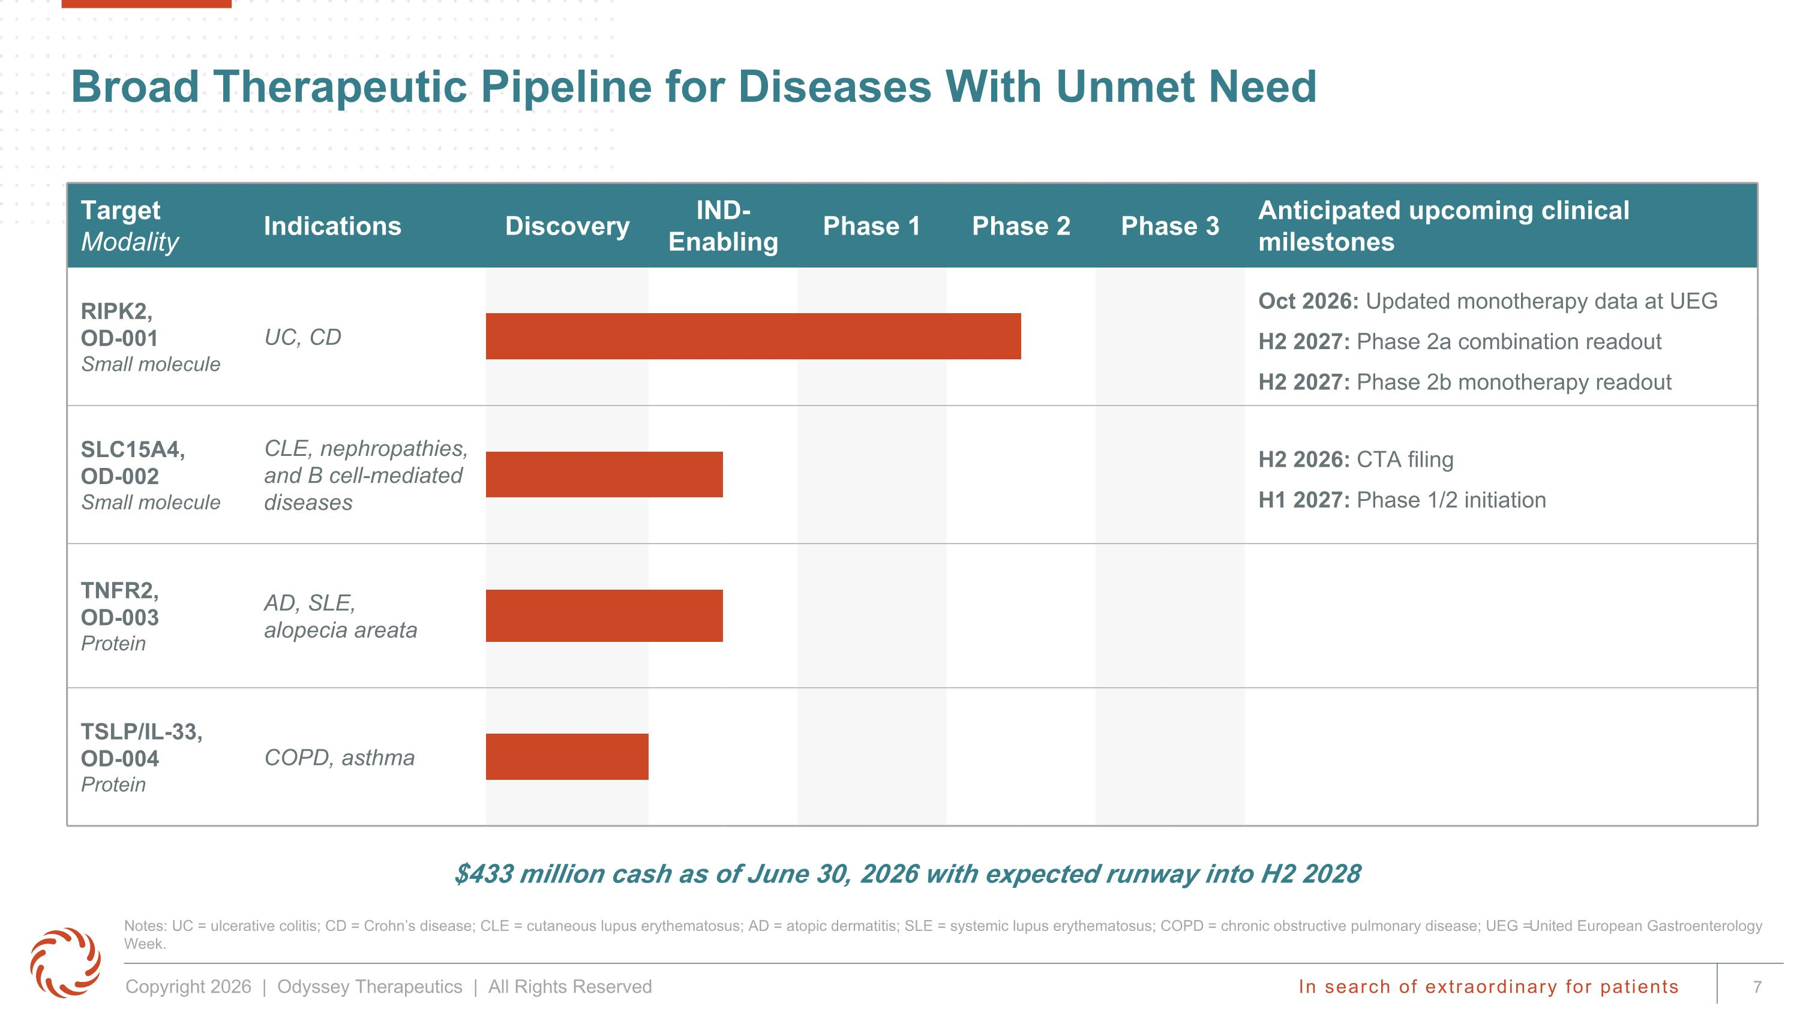
Broad Therapeutic Pipeline for Diseases With Unmet Need Notes: UC = ulcerative colitis; CD = Crohn’s disease; CLE = cutaneous lupus erythematosus; AD = atopic dermatitis; SLE = systemic lupus erythematosus; COPD = chronic obstructive pulmonary disease; UEG = United European Gastroenterology Week. Target Modality Indications Discovery IND-Enabling Phase 1 Phase 2 Phase 3 Anticipated upcoming clinical milestones RIPK2, OD-001 Small molecule UC, CD Oct 2026: Updated monotherapy data at UEG H2 2027: Phase 2a combination readout H2 2027: Phase 2b monotherapy readout SLC15A4, OD-002 Small molecule CLE, nephropathies, and B cell-mediated diseases H2 2026: CTA filing H1 2027: Phase 1/2 initiation TNFR2, OD-003 Protein AD, SLE, ?alopecia areata TSLP/IL-33, OD-004 Protein COPD, asthma $433 million cash as of June 30, 2026 with expected runway into H2 2028

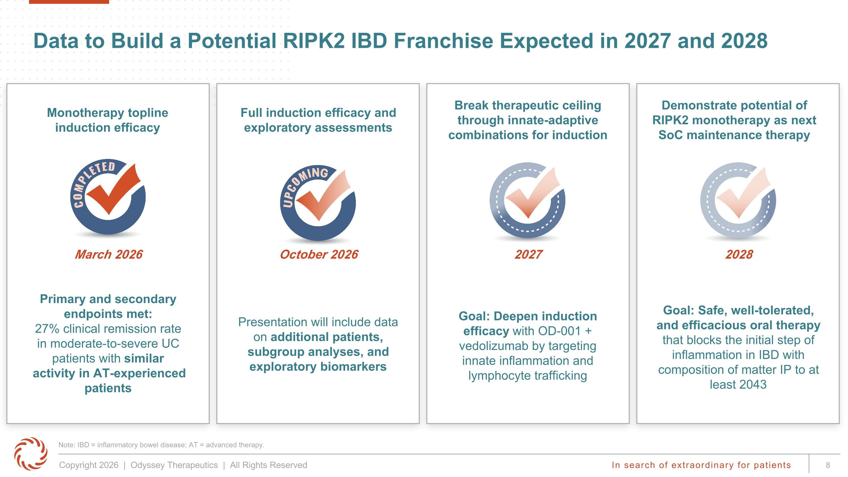
2028 Data to Build a Potential RIPK2 IBD Franchise Expected in 2027 and 2028 Monotherapy topline induction efficacy Break therapeutic ceiling through innate-adaptive combinations for induction Demonstrate potential of RIPK2 monotherapy as next SoC maintenance therapy Note: IBD = inflammatory bowel disease; AT = advanced therapy. 2027 Primary and secondary endpoints met: 27% clinical remission rate in moderate-to-severe UC patients with similar activity in AT-experienced patients March 2026 Goal: Safe, well-tolerated, and efficacious oral therapy that blocks the initial step of inflammation in IBD with composition of matter IP to at least 2043 Full induction efficacy and exploratory assessments October 2026 Presentation will include data on additional patients, subgroup analyses, and exploratory biomarkers Goal: Deepen induction efficacy with OD-001 + vedolizumab by targeting innate inflammation and lymphocyte trafficking

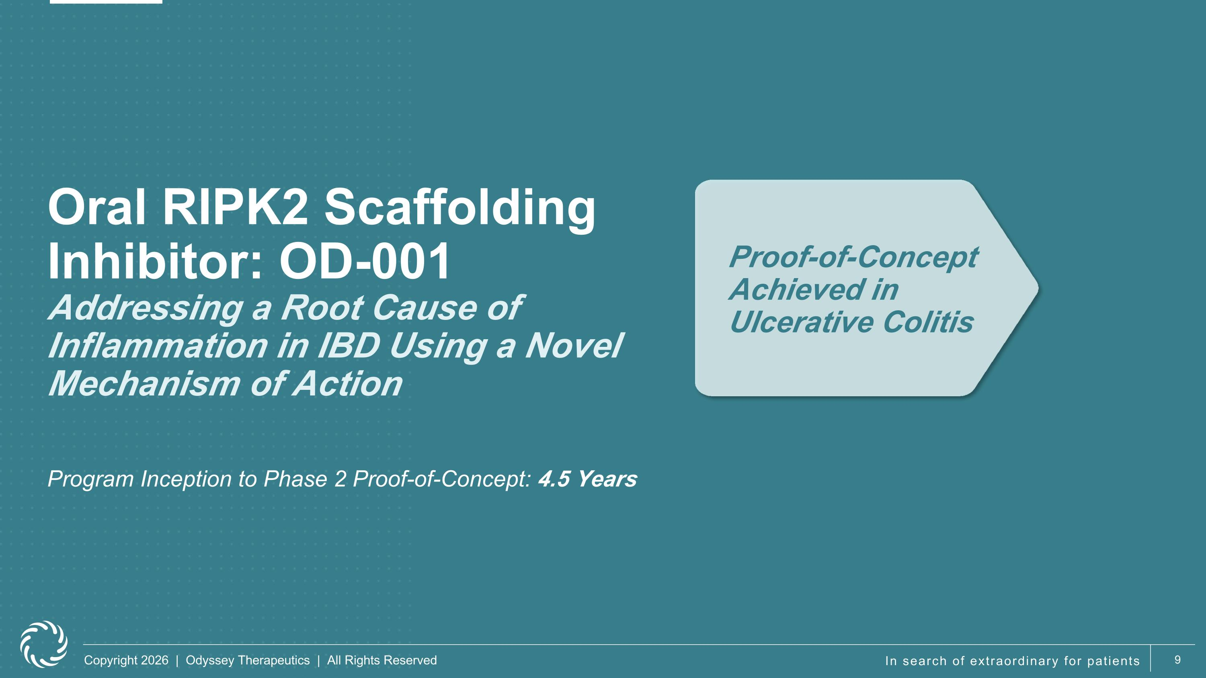
Oral RIPK2 Scaffolding Inhibitor: OD-001?Addressing a Root Cause of Inflammation in IBD Using a Novel Mechanism of Action Proof-of-Concept Achieved in Ulcerative Colitis Program Inception to Phase 2 Proof-of-Concept: 4.5 Years

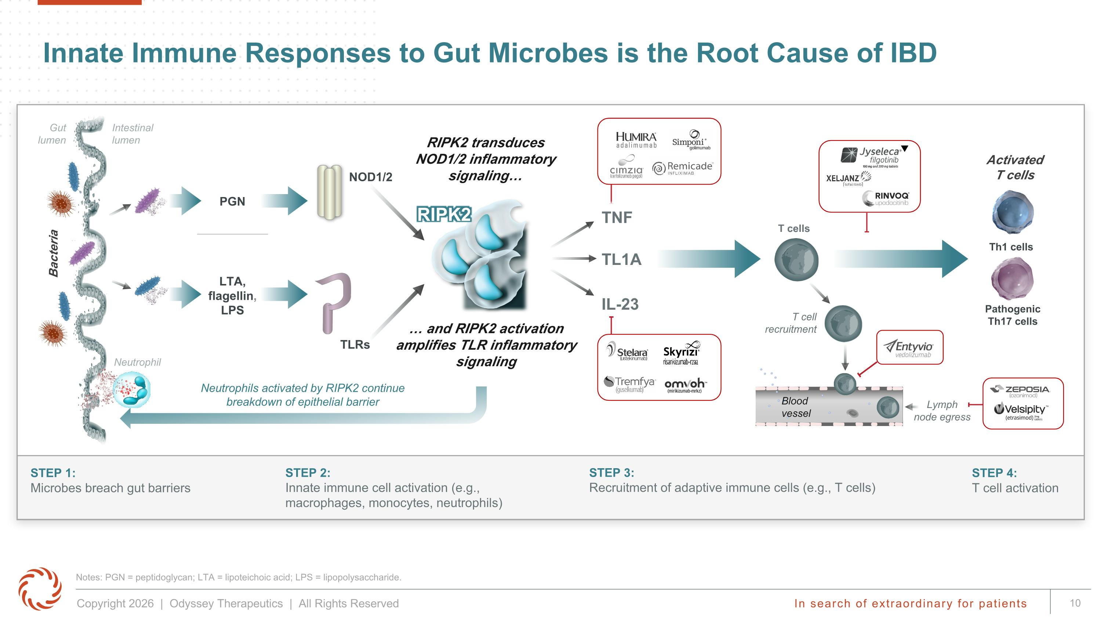
Innate Immune Responses to Gut Microbes is the Root Cause of IBD Notes: PGN = peptidoglycan; LTA = lipoteichoic acid; LPS = lipopolysaccharide. STEP 1: ?Microbes breach gut barriers STEP 2: ?Innate immune cell activation (e.g., macrophages, monocytes, neutrophils) STEP 3: ?Recruitment of adaptive immune cells (e.g., T cells) STEP 4: ?T cell activation Intestinal lumen TLRs NOD1/2 LTA, ?flagellin, ?LPS PGN T cells T cell recruitment Lymph ?node egress TNF TL1A IL-23 Blood ?vessel Bacteria Gut ?lumen Pathogenic Th17 cells Activated?T cells Th1 cells RIPK2 transduces NOD1/2 inflammatory signaling and RIPK2 activation amplifies TLR inflammatory signaling RIPK2 Neutrophils activated by RIPK2 continue ?breakdown of epithelial barrier Neutrophil

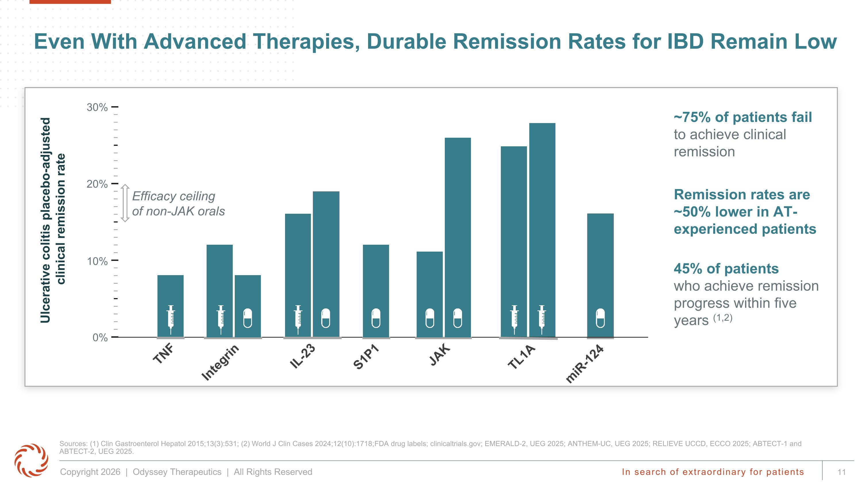
miR-124 Even With Advanced Therapies, Durable Remission Rates for IBD Remain Low Sources: (1) Clin Gastroenterol Hepatol 2015;13(3):531; (2) World J Clin Cases 2024;12(10):1718; FDA drug labels; clinicaltrials.gov; EMERALD-2, UEG 2025; ANTHEM-UC, UEG 2025; RELIEVE UCCD, ECCO 2025; ABTECT-1 and ABTECT-2, UEG 2025. ~75% of patients fail to achieve clinical remission 45% of patients ?who achieve remission progress within five years (1,2) TNF Integrin S1P1 JAK TL1A IL-23 0% 10% 20% 30% Efficacy ceiling of non-JAK orals Ulcerative colitis placebo-adjusted? clinical remission rate Remission rates are ~50% lower in AT-experienced patients

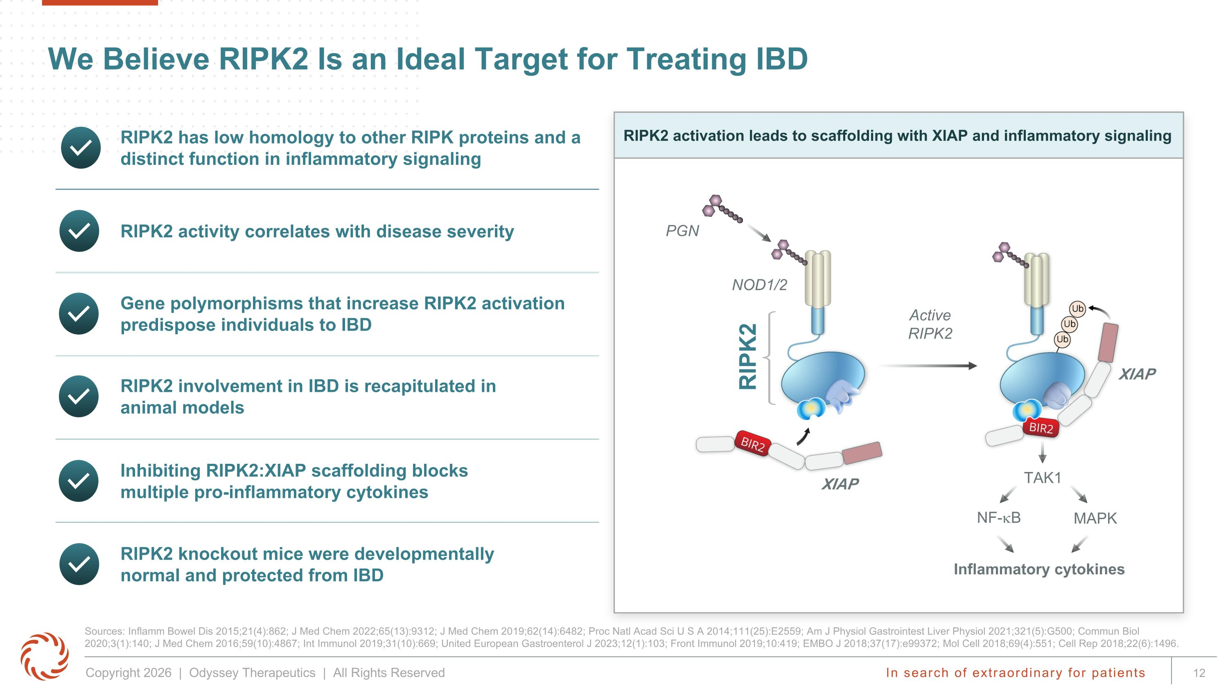
We Believe RIPK2 Is an Ideal Target for Treating IBD Sources: Inflamm Bowel Dis 2015;21(4):862; J Med Chem 2022;65(13):9312; J Med Chem 2019;62(14):6482; Proc Natl Acad Sci U S A 2014;111(25):E2559; Am J Physiol Gastrointest Liver Physiol 2021;321(5):G500; Commun Biol 2020;3(1):140; J Med Chem 2016;59(10):4867; Int Immunol 2019;31(10):669; United European Gastroenterol J 2023;12(1):103; Front Immunol 2019;10:419; EMBO J 2018;37(17):e99372; Mol Cell 2018;69(4):551; Cell Rep 2018;22(6):1496. Gene polymorphisms that increase RIPK2 activation predispose individuals to IBD RIPK2 knockout mice were developmentally normal and protected from IBD RIPK2 involvement in IBD is recapitulated in animal models Inhibiting RIPK2:XIAP scaffolding blocks multiple pro-inflammatory cytokines RIPK2 activity correlates with disease severity RIPK2 activation leads to scaffolding with XIAP and inflammatory signaling RIPK2 Inflammatory cytokines NF-kB MAPK TAK1 XIAP Active?RIPK2 NOD1/2 PGN XIAP XIAP RIPK2 has low homology to other RIPK proteins and a distinct function in inflammatory signaling

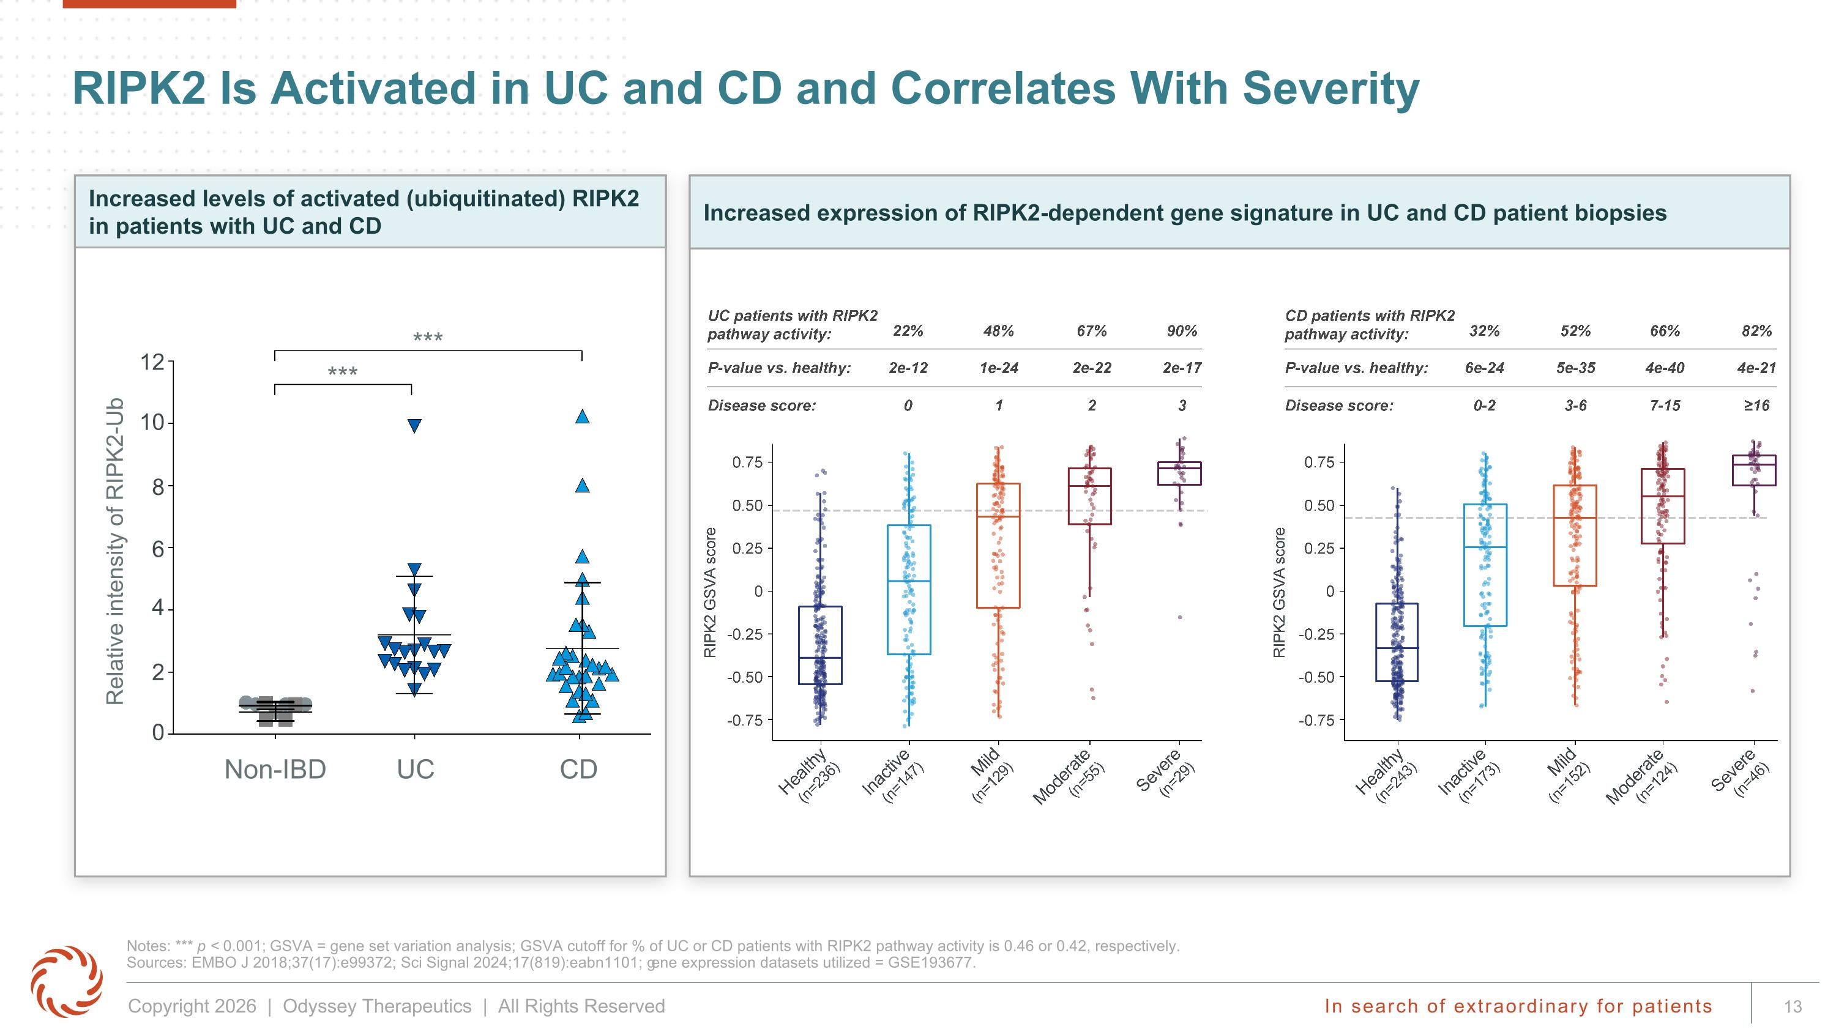
Increased expression of RIPK2-dependent gene signature in UC and CD patient biopsies RIPK2 Is Activated in UC and CD and Correlates With Severity Notes: *** p < 0.001; GSVA = gene set variation analysis; GSVA cutoff for % of UC or CD patients with RIPK2 pathway activity is 0.46 or 0.42, respectively. ?Sources: EMBO J 2018;37(17):e99372; Sci Signal 2024;17(819):eabn1101; gene expression datasets utilized = GSE193677. Relative intensity of RIPK2-Ub Non-IBD UC CD 12 10 8 6 4 2 0 *** *** Increased levels of activated (ubiquitinated) RIPK2 in patients with UC and CD

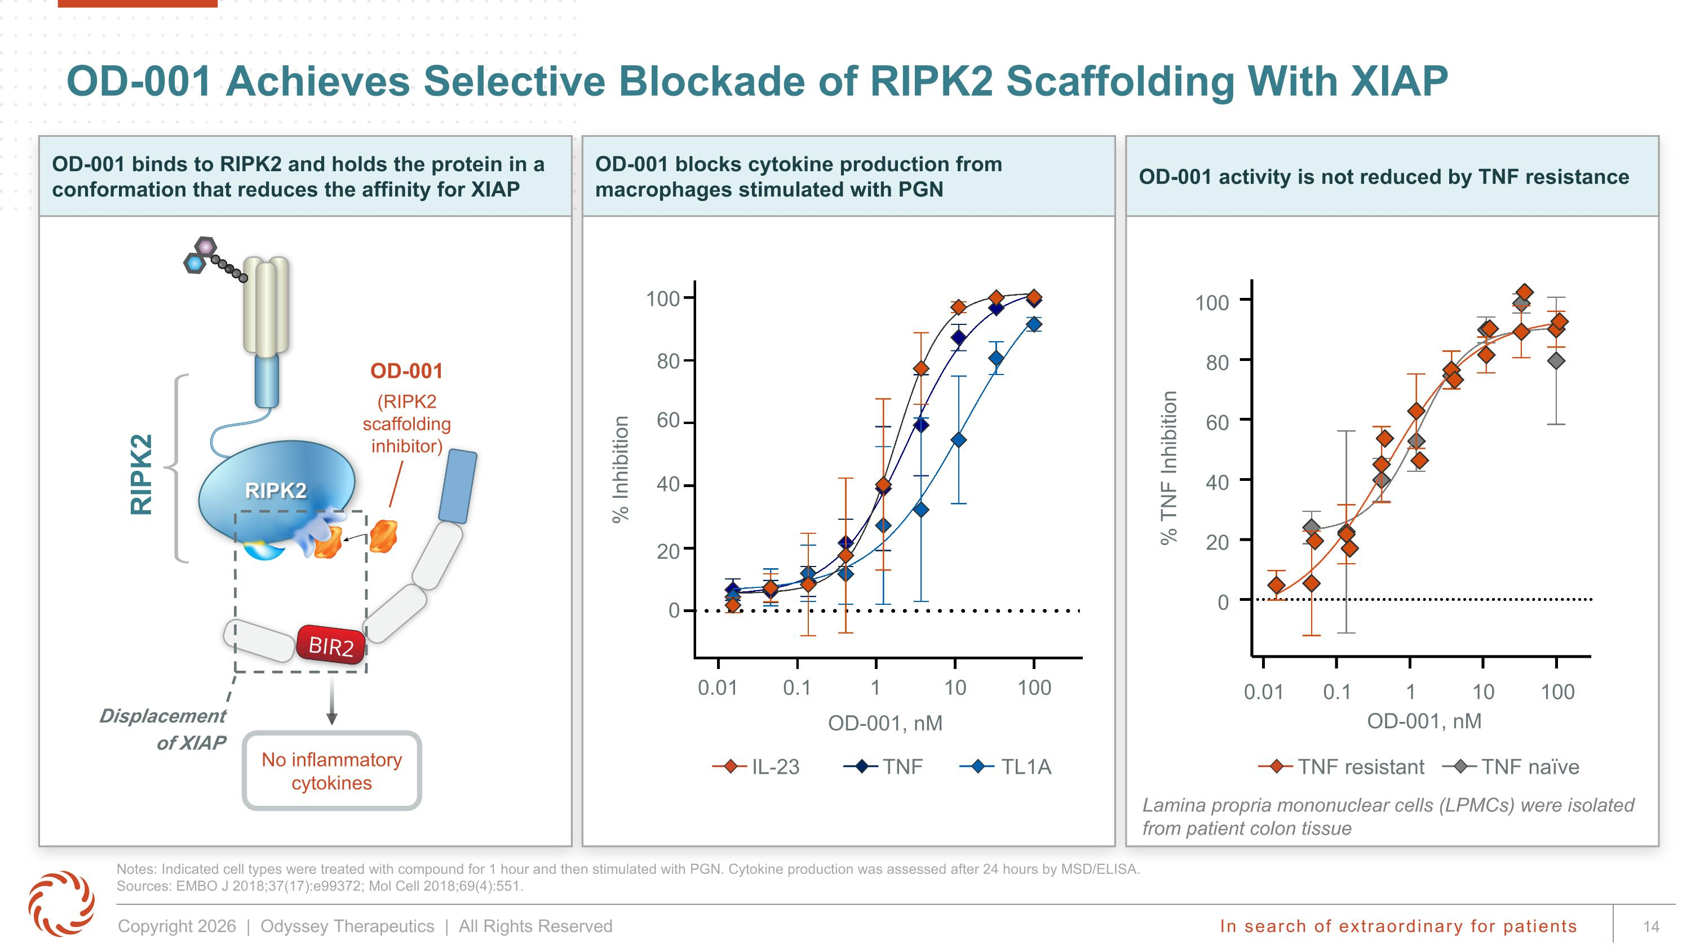
OD-001 blocks cytokine production from macrophages stimulated with PGN OD-001 activity is not reduced by TNF resistance OD-001 binds to RIPK2 and holds the protein in a conformation that reduces the affinity for XIAP RIPK2 Displacement of XIAP OD-001 (RIPK2 ?scaffolding ?inhibitor) OD-001 Achieves Selective Blockade of RIPK2 Scaffolding With XIAP Notes: Indicated cell types were treated with compound for 1 hour and then stimulated with PGN. Cytokine production was assessed after 24 hours by MSD/ELISA. Sources: EMBO J 2018;37(17):e99372; Mol Cell 2018;69(4):551. RIPK2 No inflammatory cytokines % Inhibition OD-001, nM 0.01 0.1 1 10 100 0 20 40 60 80 100 % TNF Inhibition 0 20 40 60 80 100 OD-001, nM 0.01 0.1 1 10 100 IL-23 TNF TL1A TNF resistant TNF naïve Lamina propria mononuclear cells (LPMCs) were isolated from patient colon tissue

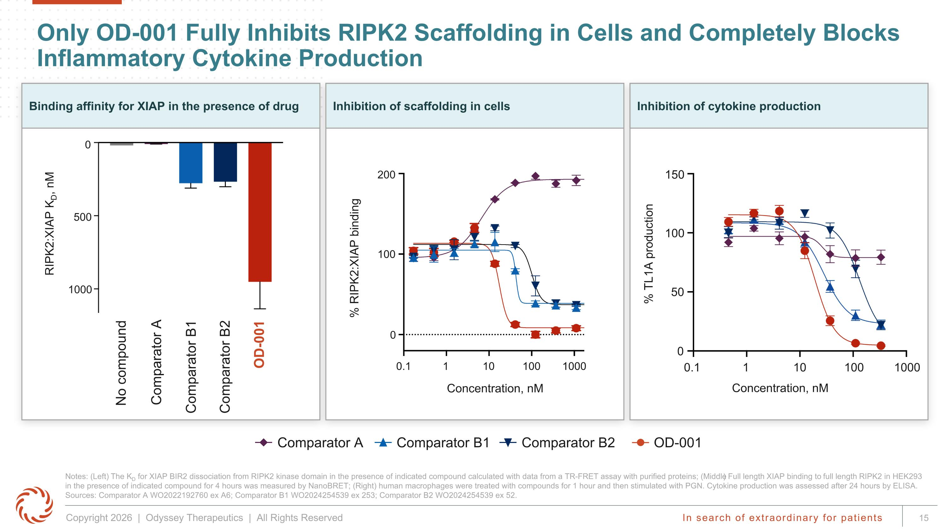
Inhibition of cytokine production Only OD-001 Fully Inhibits RIPK2 Scaffolding in Cells and Completely Blocks Inflammatory Cytokine Production Notes: (Left) The KD for XIAP BIR2 dissociation from RIPK2 kinase domain in the presence of indicated compound calculated with data from a TR-FRET assay with purified proteins; (Middle) Full length XIAP binding to full length RIPK2 in HEK293 in the presence of indicated compound for 4 hours was measured by NanoBRET; (Right) human macrophages were treated with compounds for 1 hour and then stimulated with PGN. Cytokine production was assessed after 24 hours by ELISA. Sources: Comparator A WO2022192760 ex A6; Comparator B1 WO2024254539 ex 253; Comparator B2 WO2024254539 ex 52. Inhibition of scaffolding in cells Comparator A Comparator B1 OD-001 Comparator B2 Binding affinity for XIAP in the presence of drug % RIPK2:XIAP binding Concentration, nM 1000 100 0.1 1 10 200 100 0 0 No compound Comparator A Comparator B1 Comparator B2 RIPK2:XIAP KD, nM 500 1000 OD-001 % TL1A production Concentration, nM 1000 100 0.1 1 10 150 100 0 50

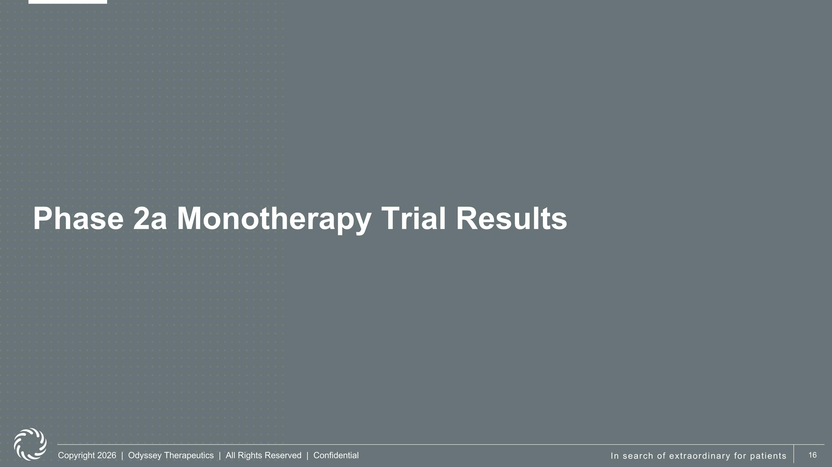
Phase 2a Monotherapy Trial Results

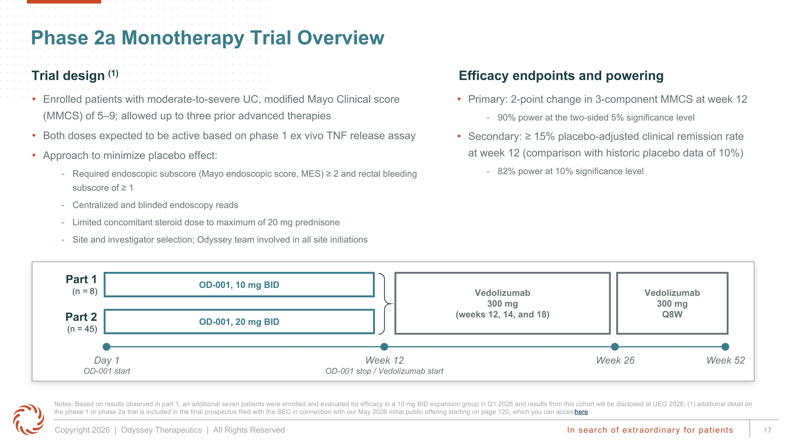
Enrolled patients with moderate-to-severe UC, modified Mayo Clinical score (MMCS) of 5–9; allowed up to three prior advanced therapies Both doses expected to be active based on phase 1 ex vivo TNF release assay Approach to minimize placebo effect: Required endoscopic subscore (Mayo endoscopic score, MES) ≥ 2 and rectal bleeding subscore of ≥ 1 Centralized and blinded endoscopy reads Limited concomitant steroid dose to maximum of 20 mg prednisone Site and investigator selection; Odyssey team involved in all site initiations Primary: 2-point change in 3-component MMCS at week 12 90% power at the two-sided 5% significance level Secondary: ≥ 15% placebo-adjusted clinical remission rate at week 12 (comparison with historic placebo data of 10%) 82% power at 10% significance level Efficacy endpoints and powering Trial design (1) Phase 2a Monotherapy Trial Overview Notes: Based on results observed in part 1, an additional seven patients were enrolled and evaluated for efficacy in a 10 mg BID expansion group in Q1 2026 and results from this cohort will be disclosed at UEG 2026; (1) additional detail on the phase 1 or phase 2a trial is included in the final prospectus filed with the SEC in connection with our May 2026 initial public offering starting on page 120, which you can access here. Vedolizumab ?300 mg ?Q8W Vedolizumab ?300 mg ?(weeks 12, 14, and 18) Day 1 OD-001 start Week 12 OD-001 stop / Vedolizumab start Week 26 Week 52 OD-001, 10 mg BID OD-001, 20 mg BID Part 1 (n = 8) Part 2?(n = 45)

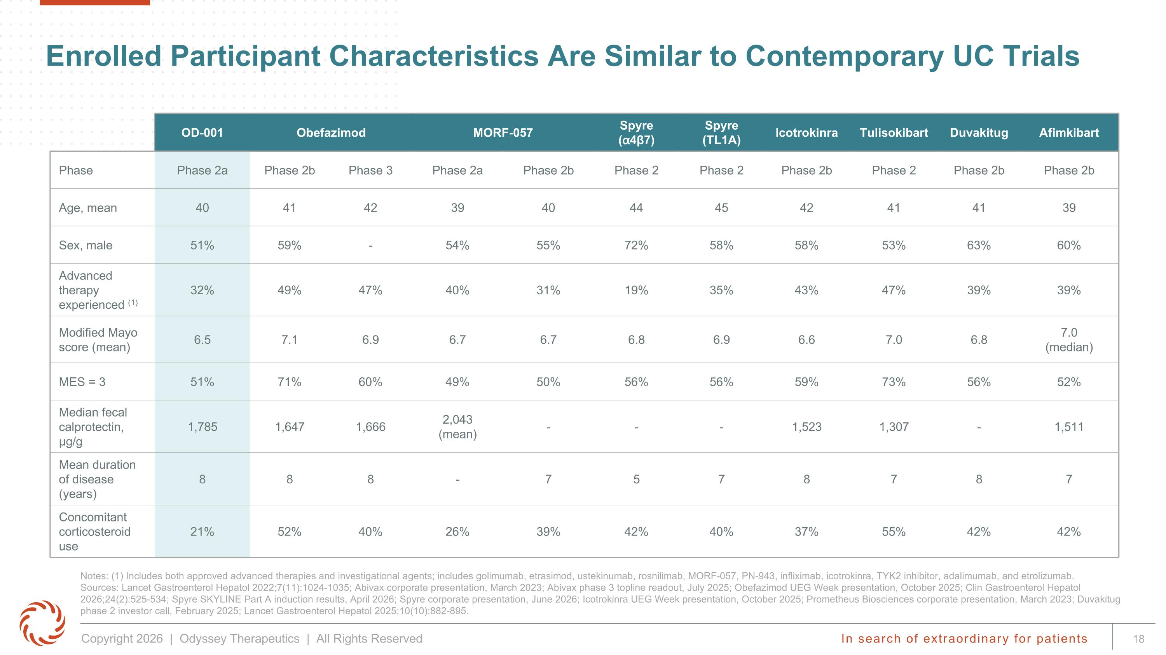
Enrolled Participant Characteristics Are Similar to Contemporary UC Trials Notes: (1) Includes both approved advanced therapies and investigational agents; includes golimumab, etrasimod, ustekinumab, rosnilimab, MORF-057, PN-943, infliximab, icotrokinra, TYK2 inhibitor, adalimumab, and etrolizumab. Sources: Lancet Gastroenterol Hepatol 2022;7(11):1024-1035; Abivax corporate presentation, March 2023; Abivax phase 3 topline readout, July 2025; Obefazimod UEG Week presentation, October 2025; Clin Gastroenterol Hepatol 2026;24(2):525-534; Spyre SKYLINE Part A induction results, April 2026; Spyre corporate presentation, June 2026; Icotrokinra UEG Week presentation, October 2025; Prometheus Biosciences corporate presentation, March 2023; Duvakitug phase 2 investor call, February 2025; Lancet Gastroenterol Hepatol 2025;10(10):882-895. OD-001 Obefazimod MORF-057 Spyre (⍺4β7) Spyre (TL1A) Icotrokinra Tulisokibart Duvakitug Afimkibart Phase Phase 2a Phase 2b Phase 3 Phase 2a Phase 2b Phase 2 Phase 2 Phase 2b Phase 2 Phase 2b Phase 2b Age, mean 40 41 42 39 40 44 45 42 41 41 39 Sex, male 51% 59% - 54% 55% 72% 58% 58% 53% 63% 60% Advanced therapy experienced (1) 32% 49% 47% 40% 31% 19% 35% 43% 47% 39% 39% Modified Mayo score (mean) 6.5 7.1 6.9 6.7 6.7 6.8 6.9 6.6 7.0 6.8 7.0 ?(median) MES = 3 51% 71% 60% 49% 50% 56% 56% 59% 73% 56% 52% Median fecal calprotectin, µg/g 1,785 1,647 1,666 2,043 ?(mean) - - - 1,523 1,307 - 1,511 Mean duration of disease (years) 8 8 8 - 7 5 7 8 7 8 7 Concomitant corticosteroid use 21% 52% 40% 26% 39% 42% 40% 37% 55% 42% 42%

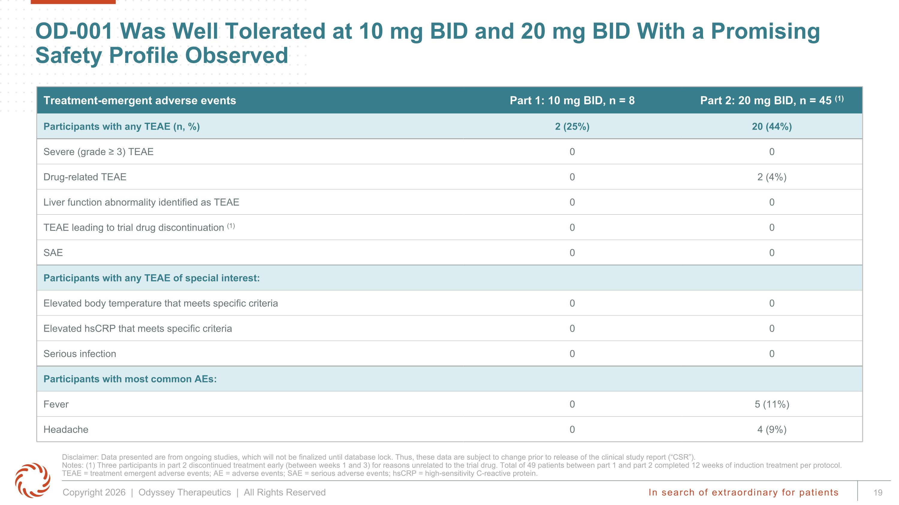
OD-001 Was Well Tolerated at 10 mg BID and 20 mg BID With a Promising Safety Profile Observed Disclaimer: Data presented are from ongoing studies, which will not be finalized until database lock. Thus, these data are subject to change prior to release of the clinical study report (“CSR”). ?Notes: (1) Three participants in part 2 discontinued treatment early (between weeks 1 and 3) for reasons unrelated to the trial drug. Total of 49 patients between part 1 and part 2 completed 12 weeks of induction treatment per protocol.?TEAE = treatment emergent adverse events; AE = adverse events; SAE = serious adverse events; hsCRP = high-sensitivity C-reactive protein. Treatment-emergent adverse events Part 1: 10 mg BID, n = 8 Part 2: 20 mg BID, n = 45 (1) Participants with any TEAE (n, %) 2 (25%) 20 (44%) Severe (grade ≥ 3) TEAE 0 0 Drug-related TEAE 0 2 (4%) Liver function abnormality identified as TEAE 0 0 TEAE leading to trial drug discontinuation (1) 0 0 SAE 0 0 Participants with any TEAE of special interest: Elevated body temperature that meets specific criteria 0 0 Elevated hsCRP that meets specific criteria 0 0 Serious infection 0 0 Participants with most common AEs: Fever 0 5 (11%) Headache 0 4 (9%)

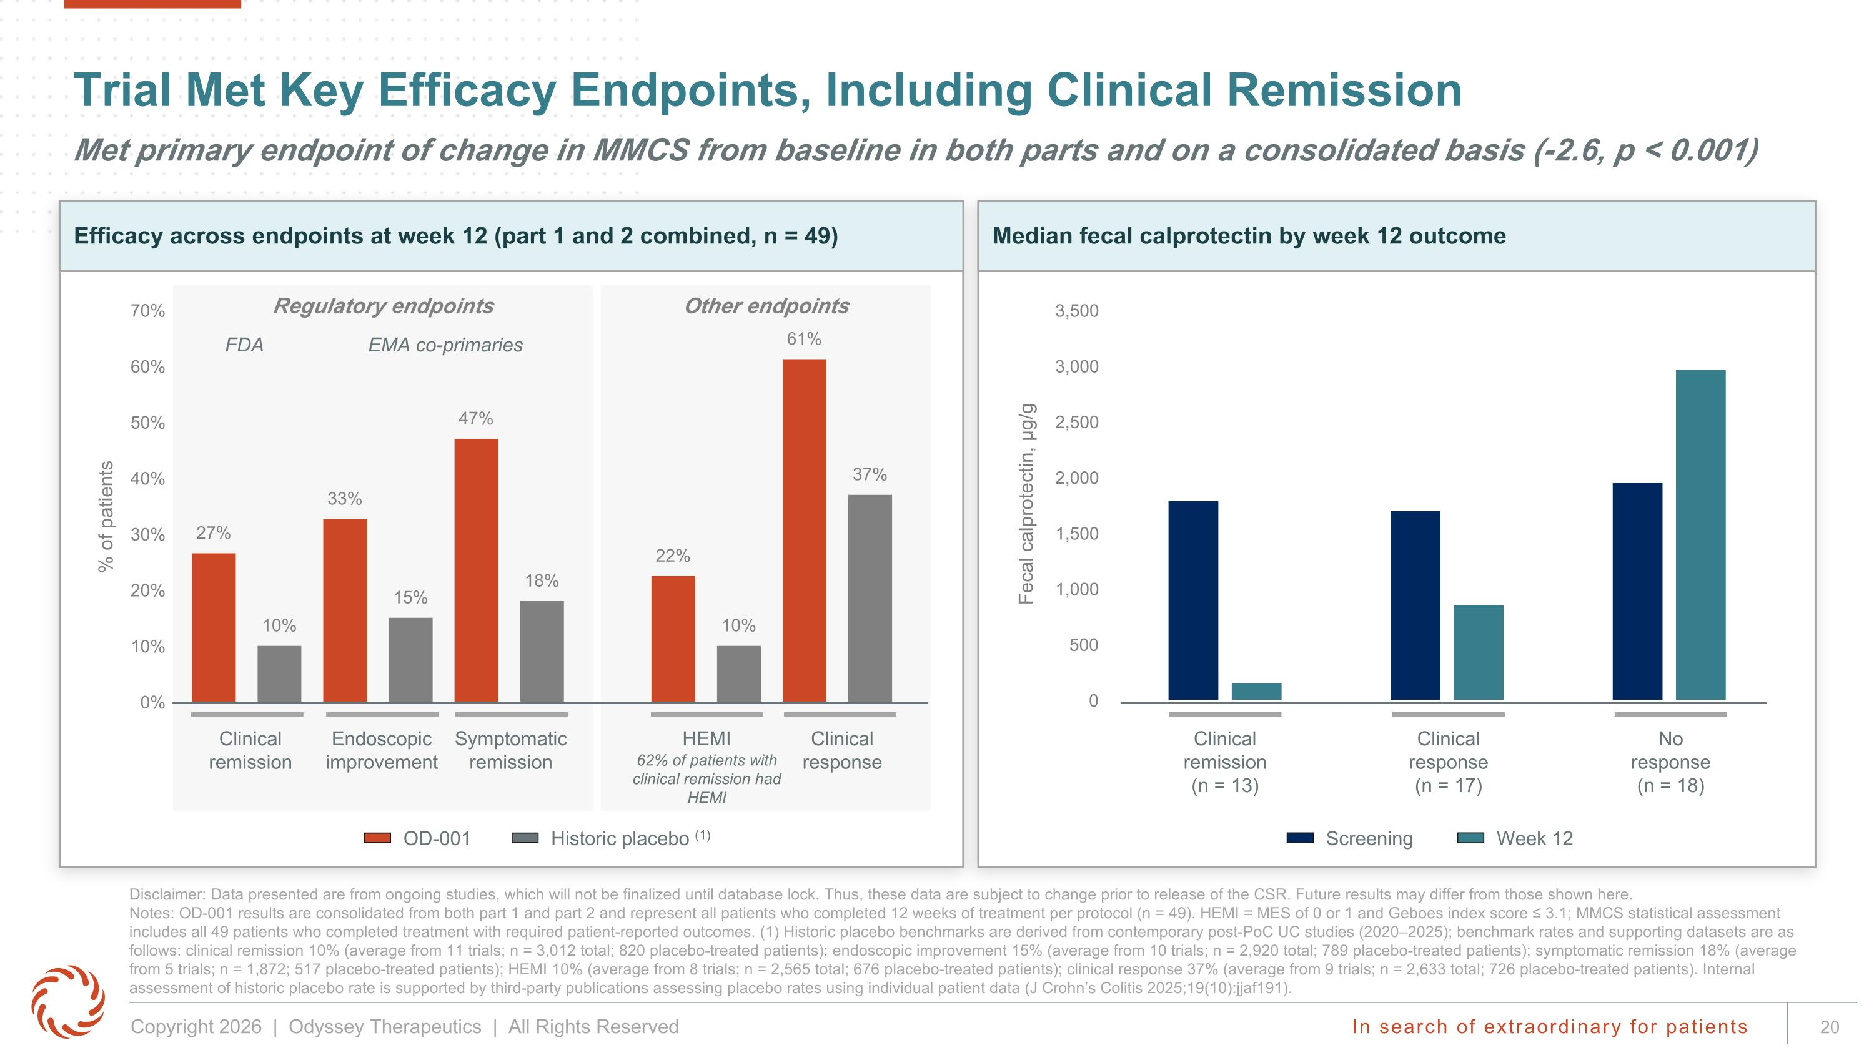
Trial Met Key Efficacy Endpoints, Including Clinical Remission Met primary endpoint of change in MMCS from baseline in both parts and on a consolidated basis (-2.6, p < 0.001) Disclaimer: Data presented are from ongoing studies, which will not be finalized until database lock. Thus, these data are subject to change prior to release of the CSR. Future results may differ from those shown here. Notes: OD-001 results are consolidated from both part 1 and part 2 and represent all patients who completed 12 weeks of treatment per protocol (n = 49). HEMI = MES of 0 or 1 and Geboes index score ≤ 3.1; MMCS statistical assessment includes all 49 patients who completed treatment with required patient-reported outcomes. (1) Historic placebo benchmarks are derived from contemporary post-PoC UC studies (2020–2025); benchmark rates and supporting datasets are as follows: clinical remission 10% (average from 11 trials; n = 3,012 total; 820 placebo-treated patients); endoscopic improvement 15% (average from 10 trials; n = 2,920 total; 789 placebo-treated patients); symptomatic remission 18% (average from 5 trials; n = 1,872; 517 placebo-treated patients); HEMI 10% (average from 8 trials; n = 2,565 total; 676 placebo-treated patients); clinical response 37% (average from 9 trials; n = 2,633 total; 726 placebo-treated patients). Internal assessment of historic placebo rate is supported by third-party publications assessing placebo rates using individual patient data (J Crohn’s Colitis 2025;19(10):jjaf191). Median fecal calprotectin by week 12 outcome Screening Week 12 Clinical remission (n = 13) Clinical response (n = 17) No response (n = 18) Other endpoints Regulatory endpoints Efficacy across endpoints at week 12 (part 1 and 2 combined, n = 49) OD-001 Historic placebo (1) Clinical remission Endoscopic improvement Symptomatic remission Clinical response HEMI 62% of patients with clinical remission had HEMI FDA EMA co-primaries

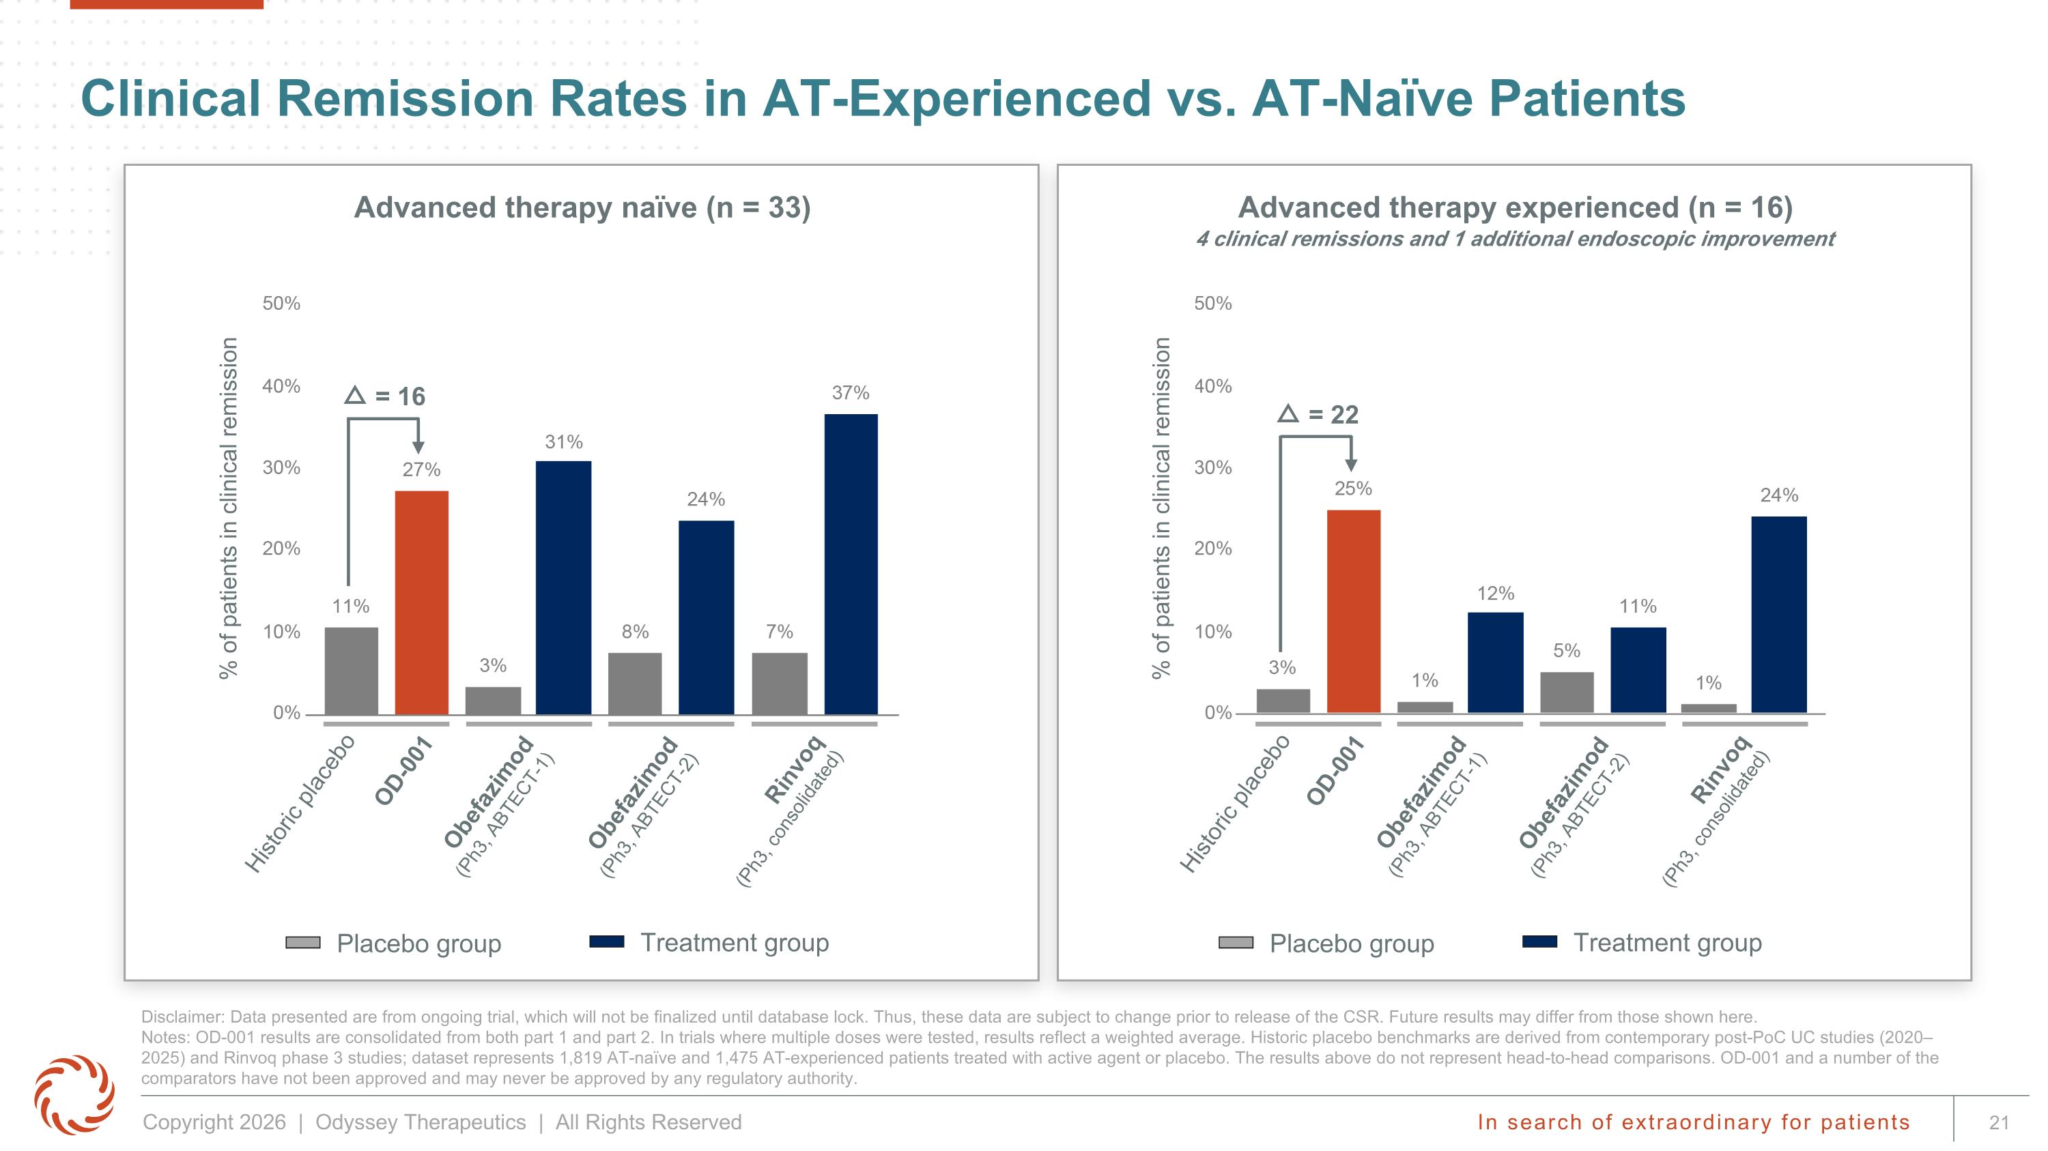
Clinical Remission Rates in AT-Experienced vs. AT-Naïve Patients Disclaimer: Data presented are from ongoing trial, which will not be finalized until database lock. Thus, these data are subject to change prior to release of the CSR. Future results may differ from those shown here. ?Notes: OD-001 results are consolidated from both part 1 and part 2. In trials where multiple doses were tested, results reflect a weighted average. Historic placebo benchmarks are derived from contemporary post-PoC UC studies (2020–2025) and Rinvoq phase 3 studies; dataset represents 1,819 AT-naïve and 1,475 AT-experienced patients treated with active agent or placebo. The results above do not represent head-to-head comparisons. OD-001 and a number of the comparators have not been approved and may never be approved by any regulatory authority. Advanced therapy naïve (n = 33) Advanced therapy experienced (n = 16) 4 clinical remissions and 1 additional endoscopic improvement Placebo group Treatment group Placebo group Treatment group Obefazimod?(Ph3, ABTECT-1) Obefazimod?(Ph3, ABTECT-2) Rinvoq?(Ph3, consolidated) Historic placebo OD-001 △ = 16 % of patients in clinical remission Obefazimod?(Ph3, ABTECT-1) Obefazimod?(Ph3, ABTECT-2) Rinvoq?(Ph3, consolidated) Historic placebo OD-001 △ = 22 % of patients in clinical remission

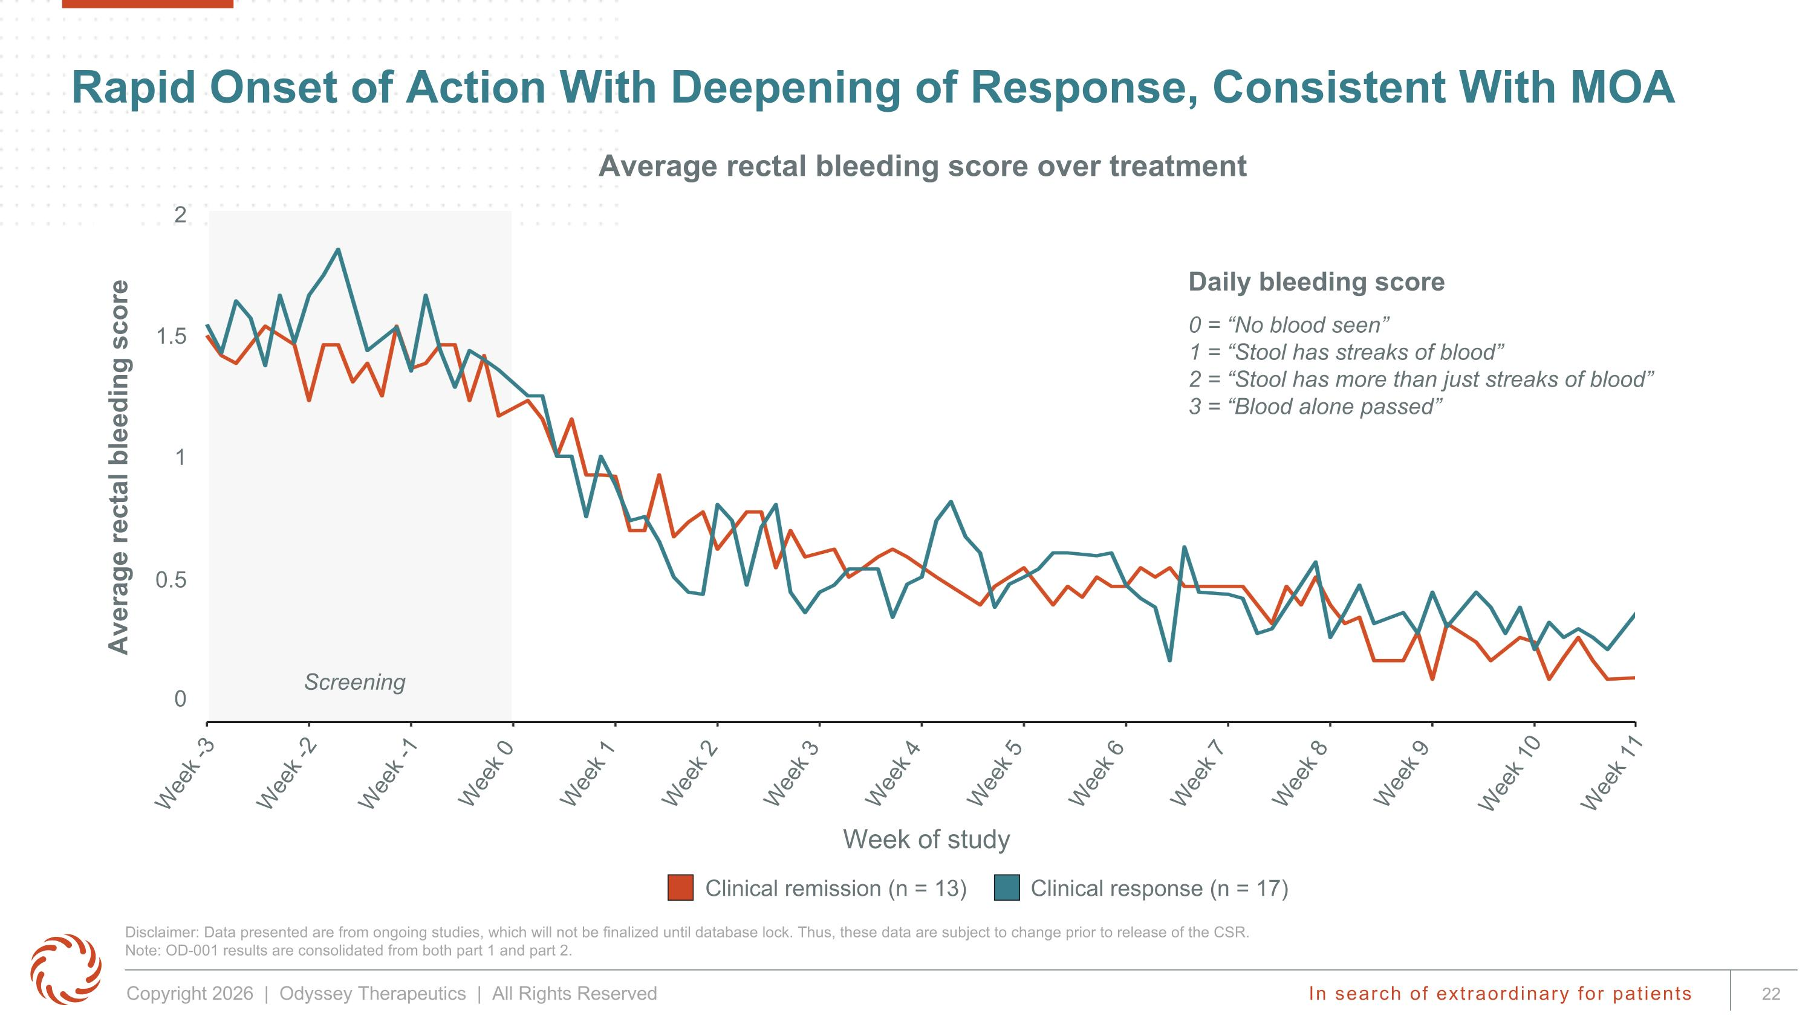
Disclaimer: Data presented are from ongoing studies, which will not be finalized until database lock. Thus, these data are subject to change prior to release of the CSR.?Note: OD-001 results are consolidated from both part 1 and part 2. Rapid Onset of Action With Deepening of Response, Consistent With MOA Screening Clinical remission (n = 13) Clinical response (n = 17) Average rectal bleeding score Daily bleeding score 0 = “No blood seen”?1 = “Stool has streaks of blood”?2 = “Stool has more than just streaks of blood”?3 = “Blood alone passed” Week -3 Week -2 Week 0 Week 1 Week 3 Week 4 Week 6 Week 7 Week 9 Week 10 Week 11 Week 8 Week -1 Week 2 Week 5 0 0.5 1 1.5 2 Week of study Average rectal bleeding score over treatment

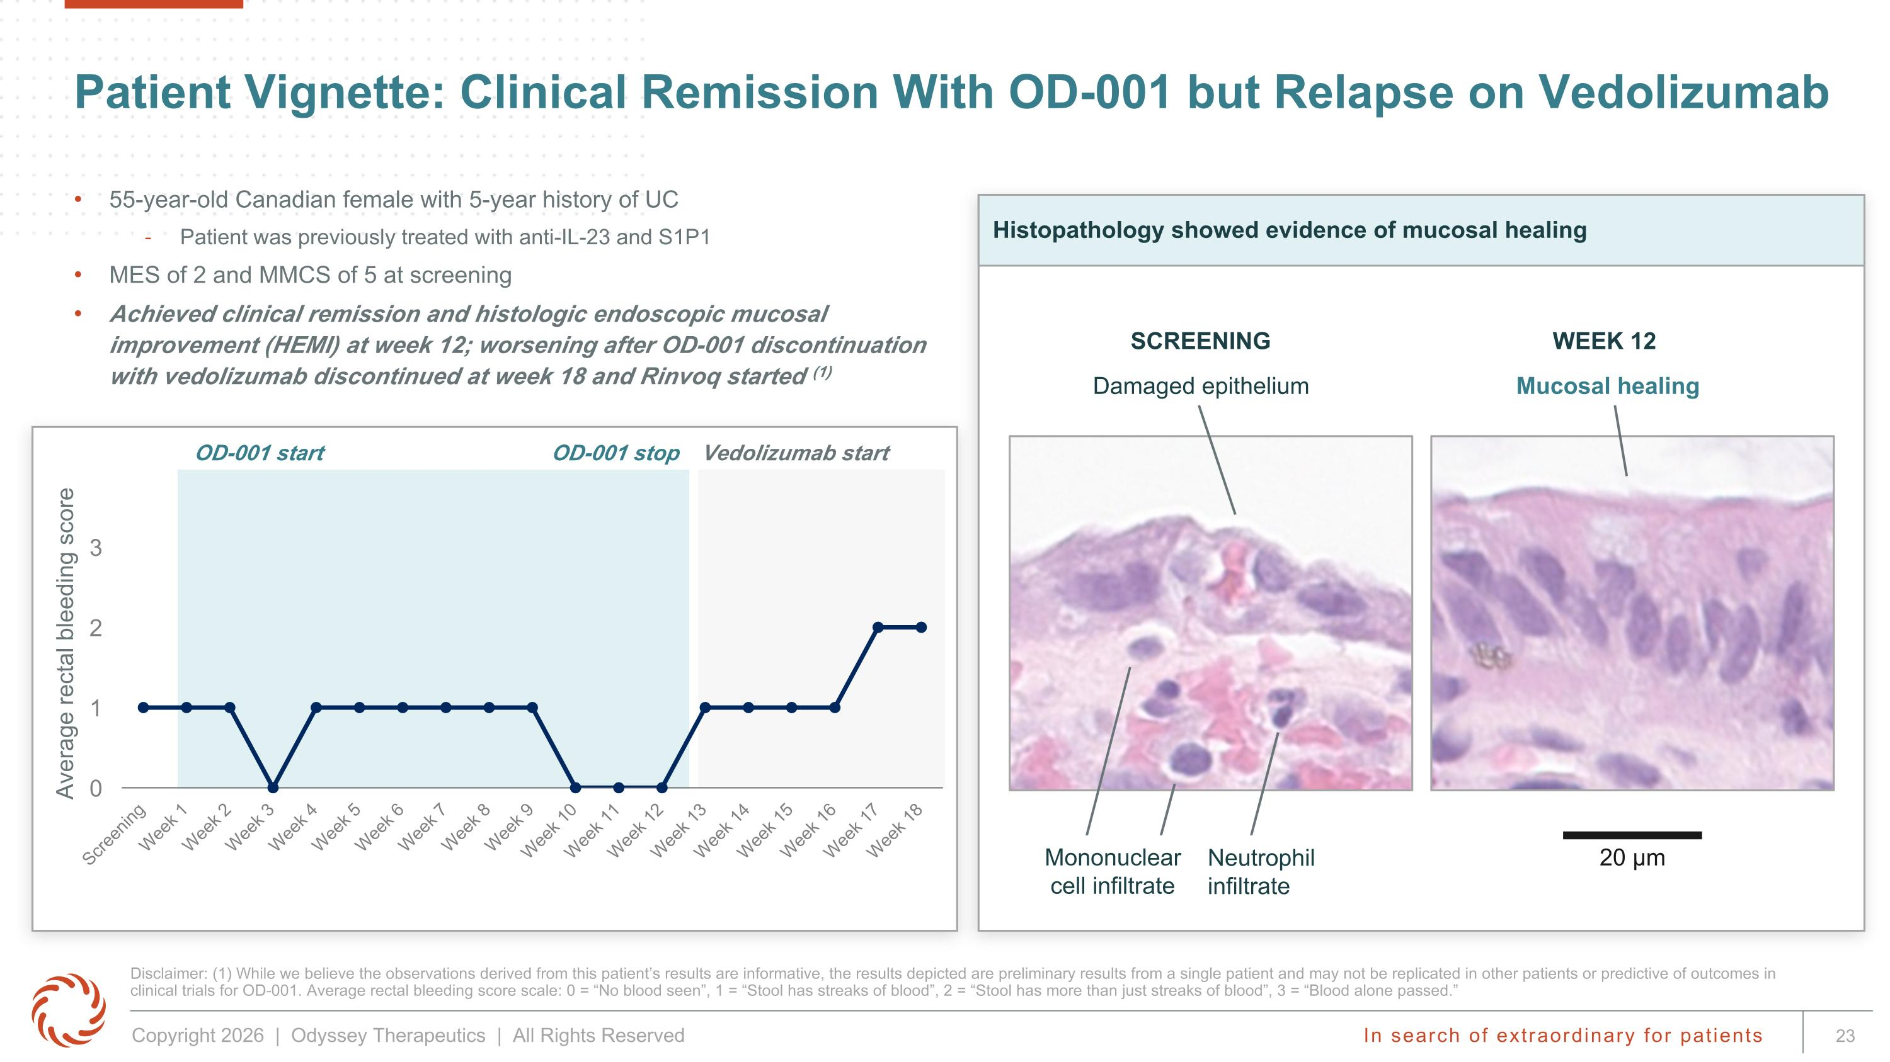
OD-001 start OD-001 stop Vedolizumab start Patient Vignette: Clinical Remission With OD-001 but Relapse on Vedolizumab 55-year-old Canadian female with 5-year history of UC Patient was previously treated with anti-IL-23 and S1P1 MES of 2 and MMCS of 5 at screening Achieved clinical remission and histologic endoscopic mucosal improvement (HEMI) at week 12; worsening after OD-001 discontinuation with vedolizumab discontinued at week 18 and Rinvoq started (1) Disclaimer: (1) While we believe the observations derived from this patient’s results are informative, the results depicted are preliminary results from a single patient and may not be replicated in other patients or predictive of outcomes in clinical trials for OD-001. Average rectal bleeding score scale: 0 = “No blood seen”, 1 = “Stool has streaks of blood”, 2 = “Stool has more than just streaks of blood”, 3 = “Blood alone passed.” Histopathology showed evidence of mucosal healing Damaged epithelium Mucosal healing SCREENING WEEK 12 Average rectal bleeding score 20 µm Neutrophil ?infiltrate Mononuclear ?cell infiltrate

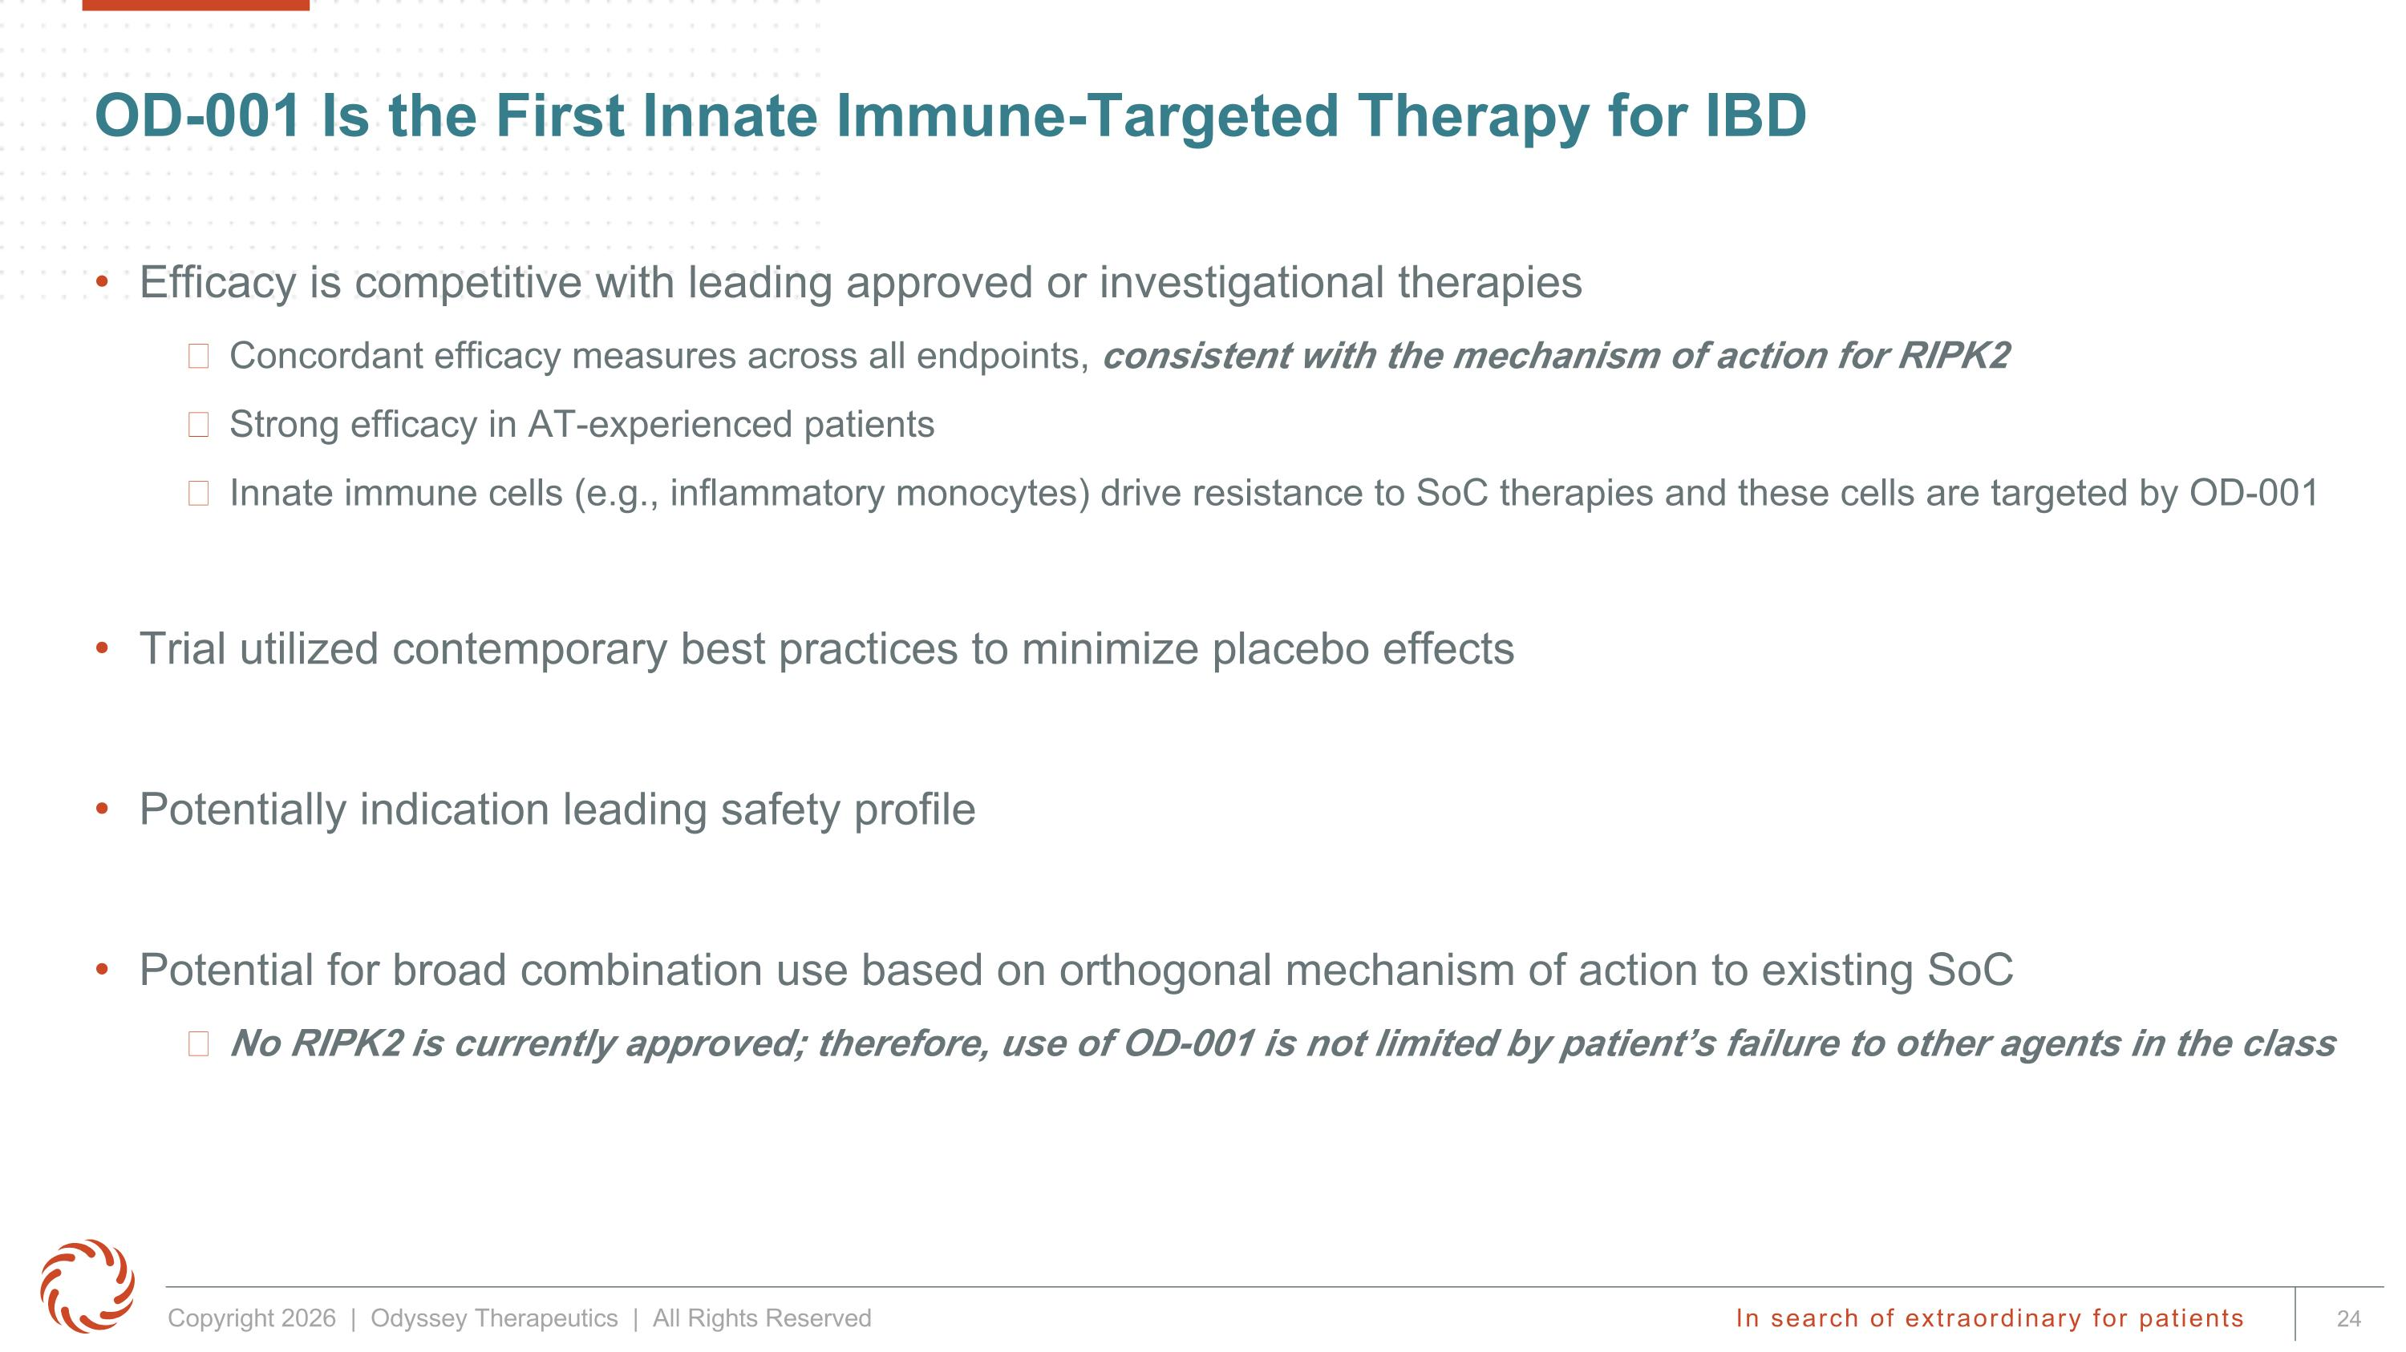
OD-001 Is the First Innate Immune-Targeted Therapy for IBD Efficacy is competitive with leading approved or investigational therapies Concordant efficacy measures across all endpoints, consistent with the mechanism of action for RIPK2 Strong efficacy in AT-experienced patients Innate immune cells (e.g., inflammatory monocytes) drive resistance to SoC therapies and these cells are targeted by OD-001 Trial utilized contemporary best practices to minimize placebo effects Potentially indication leading safety profile Potential for broad combination use based on orthogonal mechanism of action to existing SoC No RIPK2 is currently approved; therefore, use of OD-001 is not limited by patient’s failure to other agents in the class

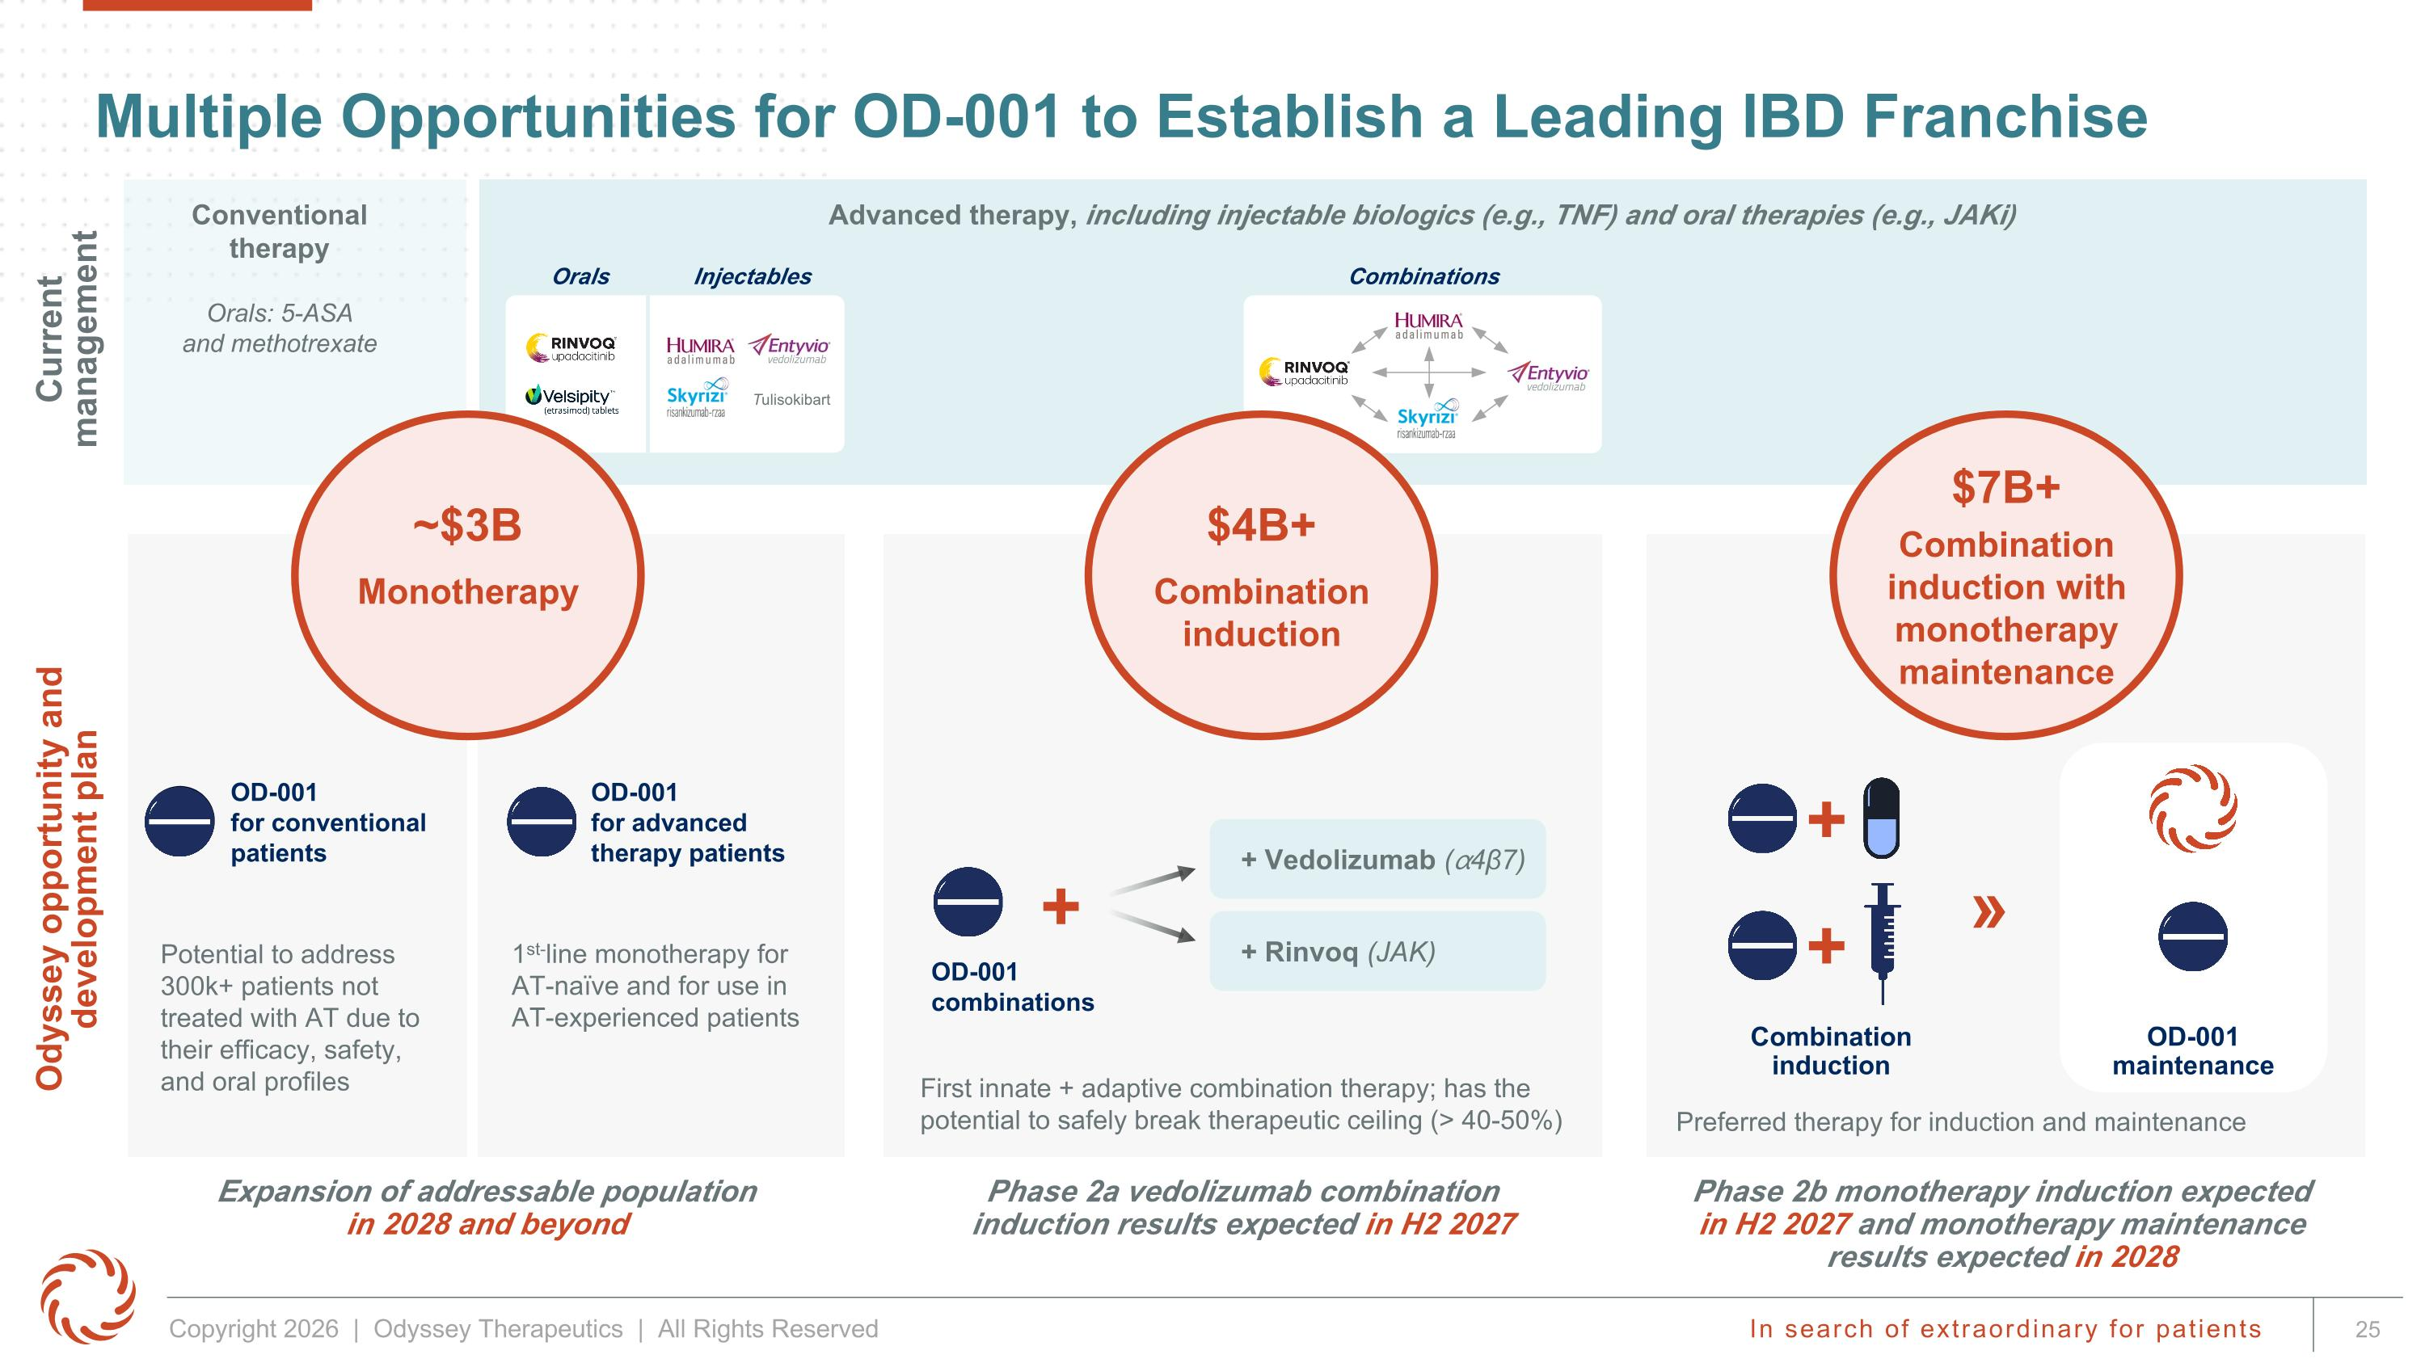
Multiple Opportunities for OD-001 to Establish a Leading IBD Franchise Conventional therapy Phase 2a vedolizumab combination ?induction results expected in H2 2027 Phase 2b monotherapy induction expected in H2 2027 and monotherapy maintenance results expected in 2028 Expansion of addressable population?in 2028 and beyond Potential to address 300k+ patients not treated with AT due to their efficacy, safety, and oral profiles First innate + adaptive combination therapy; has the potential to safely break therapeutic ceiling (> 40-50%) Current management Odyssey opportunity and development plan 1st-line monotherapy for AT-naïve and for use in AT-experienced patients Tulisokibart Combination induction OD-001 maintenance » + Orals: 5-ASA ?and methotrexate OD-001 ?for conventional patients OD-001?for advanced therapy patients Advanced therapy, including injectable biologics (e.g., TNF) and oral therapies (e.g., JAKi) Orals Injectables Combinations $4B+ Combination induction $7B+ Combination induction with monotherapy maintenance ~$3B Monotherapy OD-001 combinations + + Vedolizumab (⍺4β7) + Rinvoq (JAK) Preferred therapy for induction and maintenance +

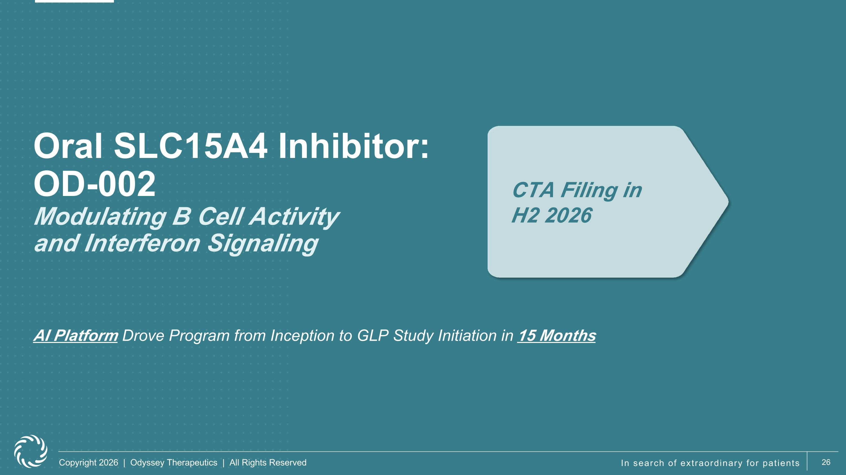
Oral SLC15A4 Inhibitor: OD-002?Modulating B Cell Activity ?and Interferon Signaling CTA Filing in ?H2 2026 AI Platform Drove Program from Inception to GLP Study Initiation in 15 Months

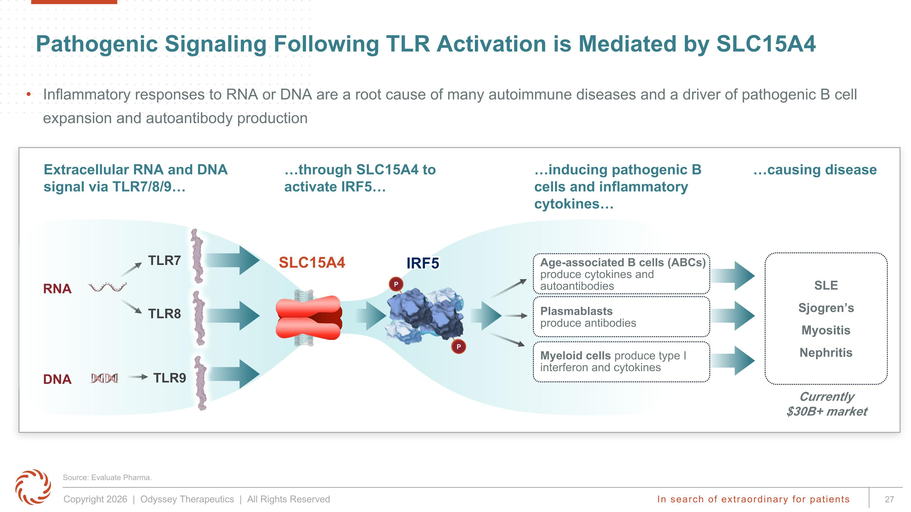
Pathogenic Signaling Following TLR Activation is Mediated by SLC15A4 Extracellular RNA and DNA signal via TLR7/8/9 through SLC15A4 to ?activate IRF5 inducing pathogenic B cells and inflammatory cytokines causing disease Myeloid cells produce type I interferon and cytokines Age-associated B cells (ABCs) produce cytokines and autoantibodies Plasmablasts ?produce antibodies TLR8 TLR7 TLR9 SLE Sjogren’s Myositis Nephritis RNA SLC15A4 IRF5 P P DNA Currently $30B+ market Source: Evaluate Pharma. Inflammatory responses to RNA or DNA are a root cause of many autoimmune diseases and a driver of pathogenic B cell expansion and autoantibody production

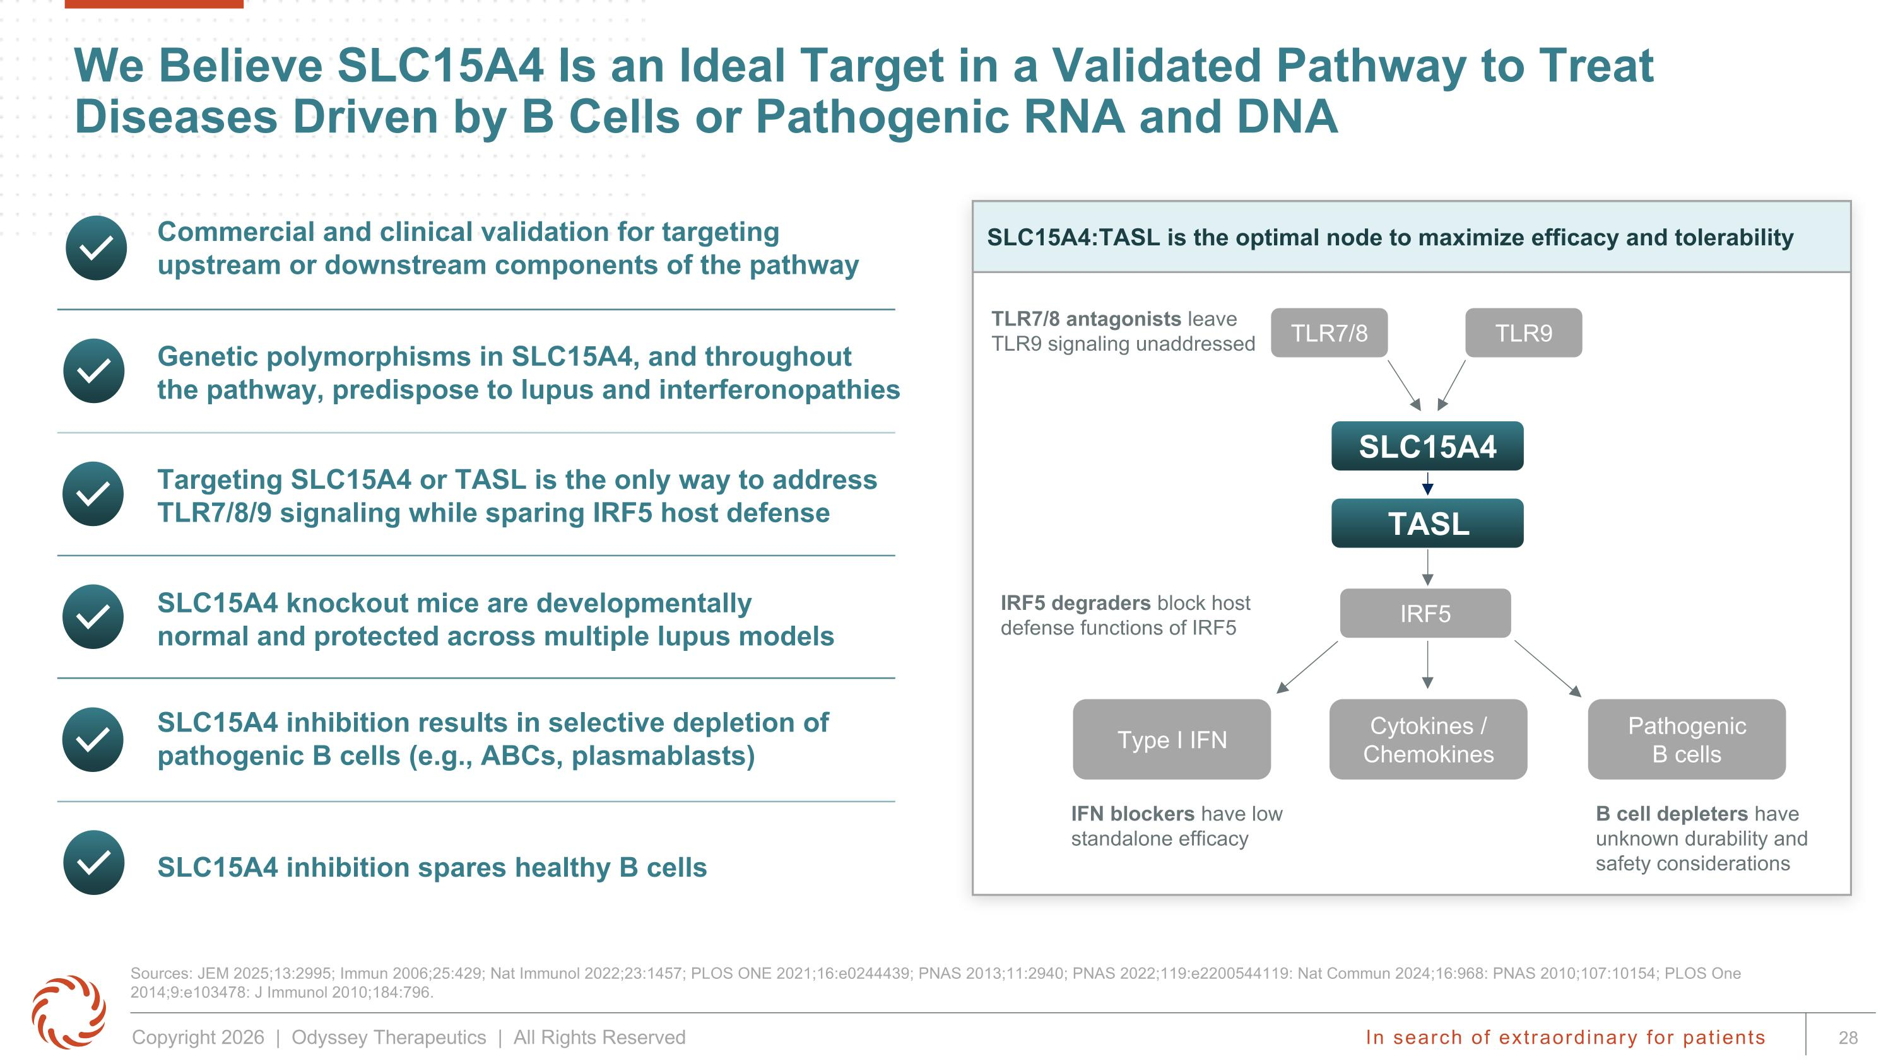
Type I IFN Pathogenic ?B cells Cytokines / Chemokines TASL We Believe SLC15A4 Is an Ideal Target in a Validated Pathway to Treat Diseases Driven by B Cells or Pathogenic RNA and DNA Sources: JEM 2025;13:2995; Immun 2006;25:429; Nat Immunol 2022;23:1457; PLOS ONE 2021;16:e0244439; PNAS 2013;11:2940; PNAS 2022;119:e2200544119: Nat Commun 2024;16:968: PNAS 2010;107:10154; PLOS One 2014;9:e103478: J Immunol 2010;184:796. Targeting SLC15A4 or TASL is the only way to address TLR7/8/9 signaling while sparing IRF5 host defense SLC15A4 inhibition results in selective depletion of pathogenic B cells (e.g., ABCs, plasmablasts) SLC15A4 knockout mice are developmentally normal and protected across multiple lupus models Commercial and clinical validation for targeting upstream or downstream components of the pathway Genetic polymorphisms in SLC15A4, and throughout the pathway, predispose to lupus and interferonopathies SLC15A4 inhibition spares healthy B cells SLC15A4:TASL is the optimal node to maximize efficacy and tolerability TLR7/8 antagonists leave TLR9 signaling unaddressed IRF5 degraders block host defense functions of IRF5 IFN blockers have low standalone efficacy B cell depleters have unknown durability and safety considerations TLR7/8 TLR9 IRF5 SLC15A4

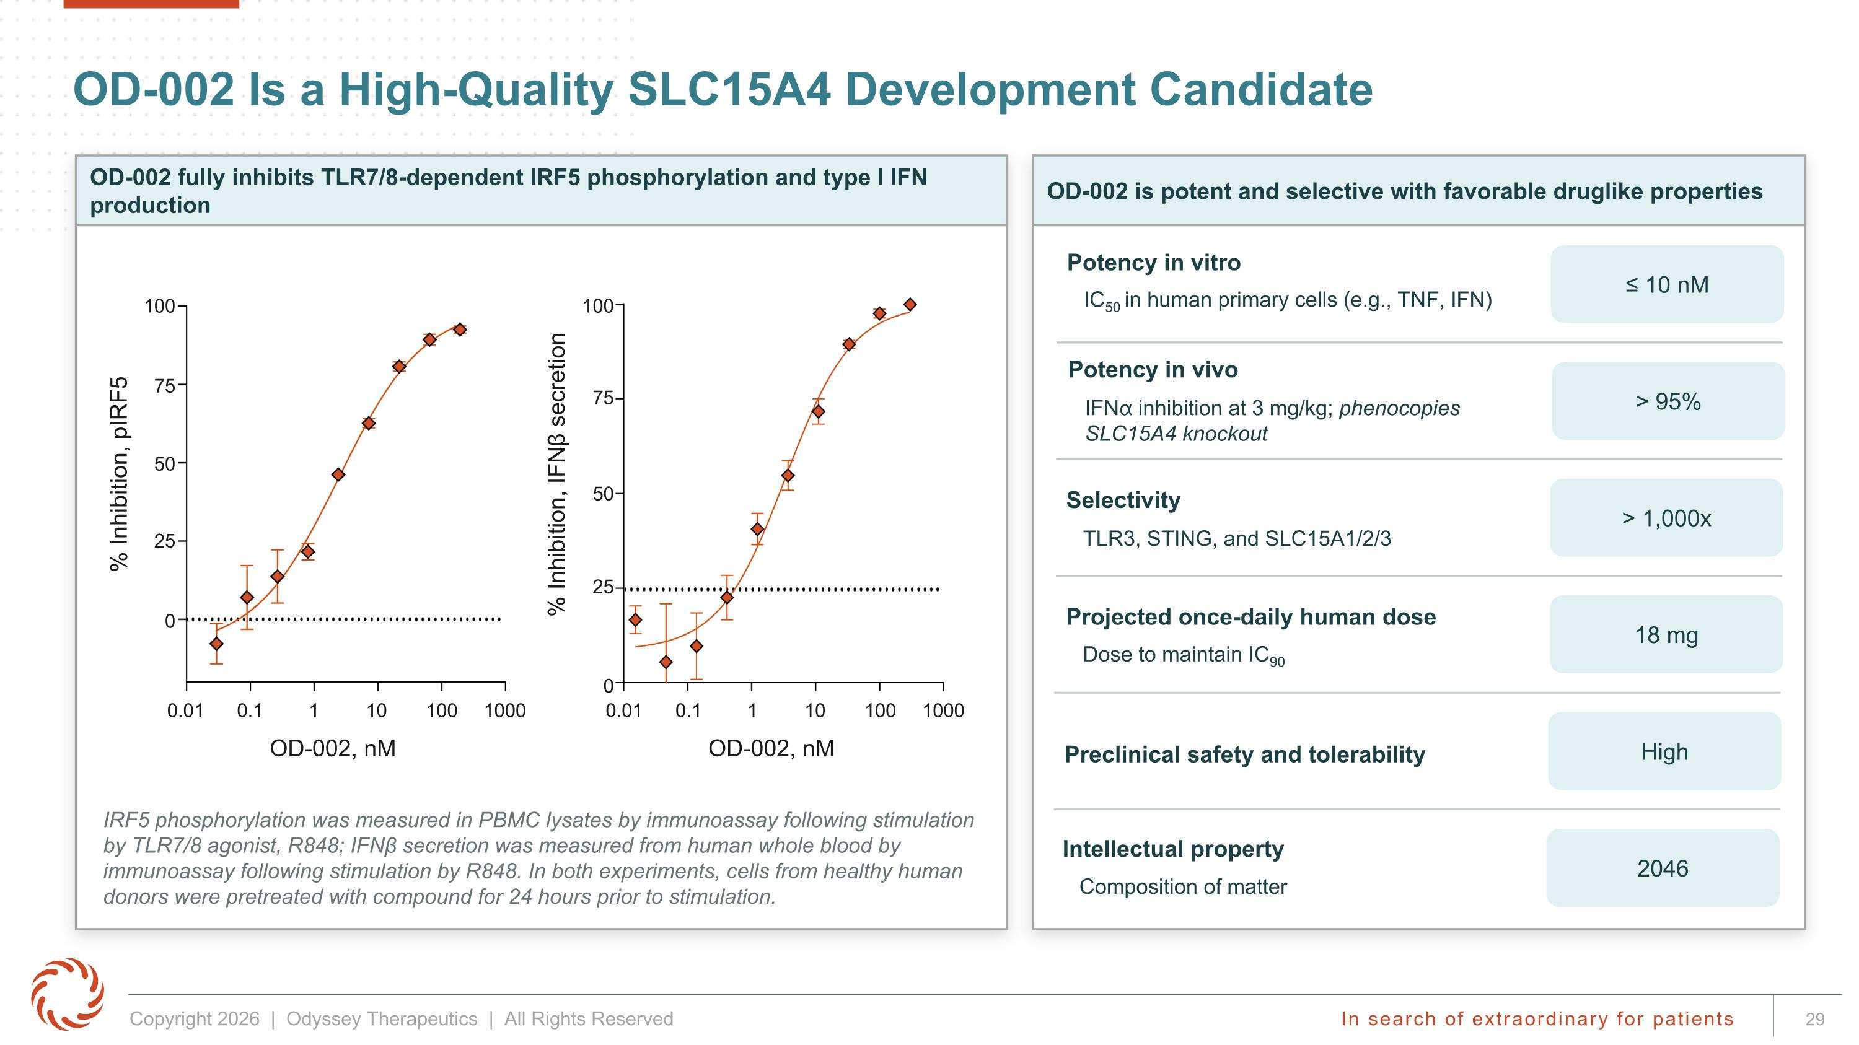
OD-002 is potent and selective with favorable druglike properties OD-002 Is a High-Quality SLC15A4 Development Candidate Potency in vitro IC50 in human primary cells (e.g., TNF, IFN) Projected once-daily human dose Dose to maintain IC90 Preclinical safety and tolerability Selectivity TLR3, STING, and SLC15A1/2/3 ≤ 10 nM > 1,000x 18 mg High Intellectual property Composition of matter 2046 Potency in vivo IFN⍺ inhibition at 3 mg/kg; phenocopies SLC15A4 knockout > 95% OD-002 fully inhibits TLR7/8-dependent IRF5 phosphorylation and type I IFN production IRF5 phosphorylation was measured in PBMC lysates by immunoassay following stimulation by TLR7/8 agonist, R848; IFNβ secretion was measured from human whole blood by immunoassay following stimulation by R848. In both experiments, cells from healthy human donors were pretreated with compound for 24 hours prior to stimulation. % Inhibition, pIRF5 100 75 50 25 0 0.01 0.1 1 10 100 1000 OD-002, nM % Inhibition, IFNβ secretion 100 75 50 25 0 0.01 0.1 1 10 100 1000 OD-002, nM

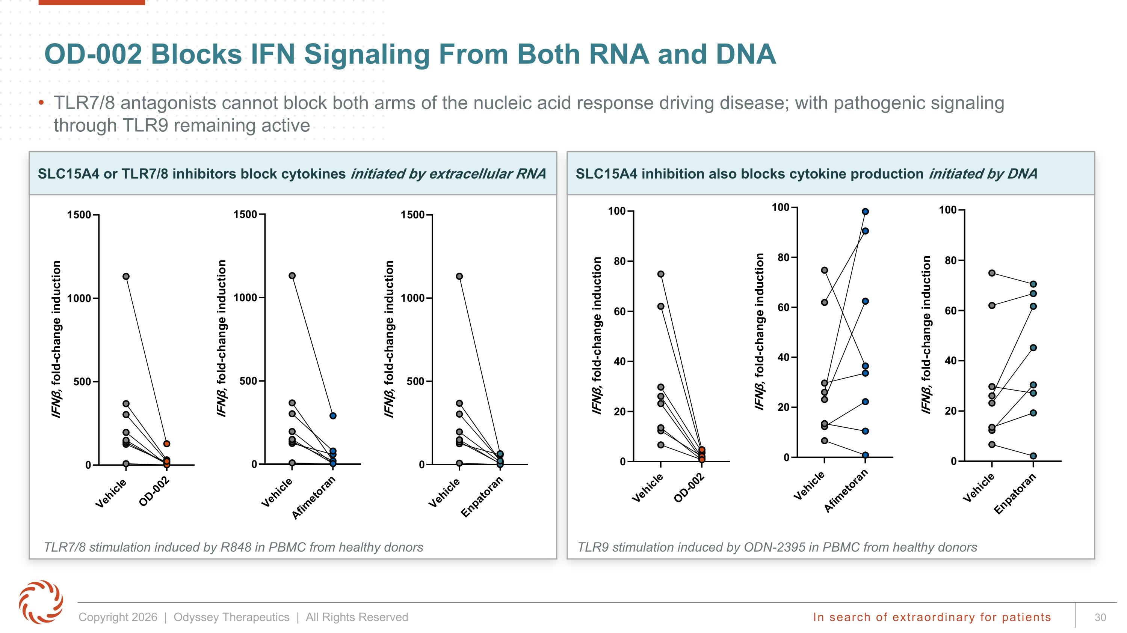
OD-002 Blocks IFN Signaling From Both RNA and DNA SLC15A4 or TLR7/8 inhibitors block cytokines initiated by extracellular RNA TLR7/8 antagonists cannot block both arms of the nucleic acid response driving disease; with pathogenic signaling through TLR9 remaining active TLR7/8 stimulation induced by R848 in PBMC from healthy donors TLR9 stimulation induced by ODN-2395 in PBMC from healthy donors SLC15A4 inhibition also blocks cytokine production initiated by DNA

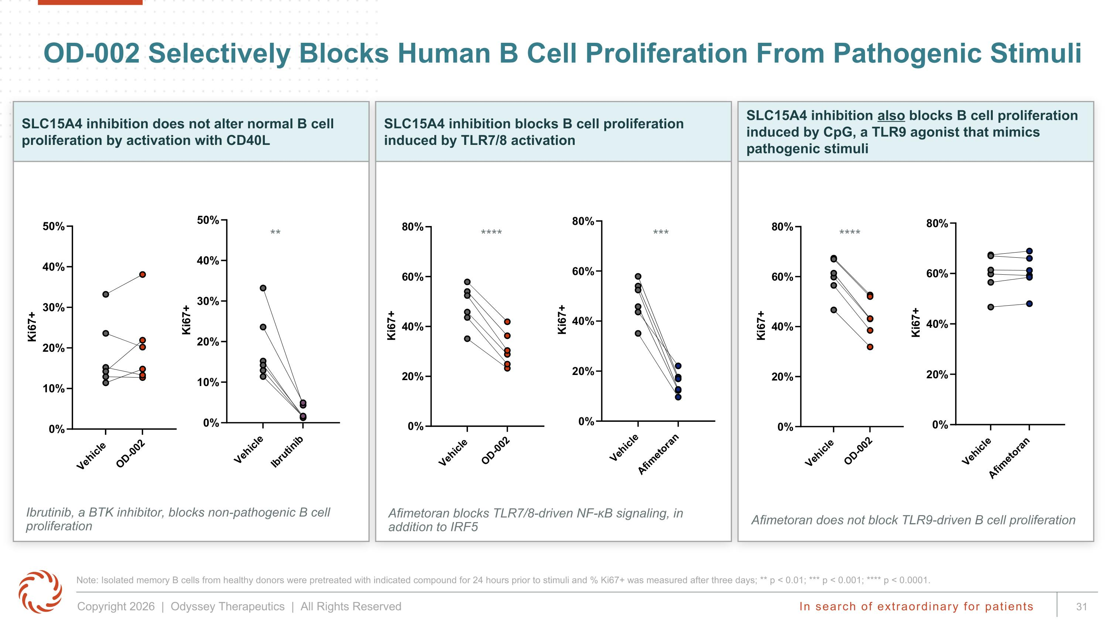
OD-002 Selectively Blocks Human B Cell Proliferation From Pathogenic Stimuli Note: Isolated memory B cells from healthy donors were pretreated with indicated compound for 24 hours prior to stimuli and % Ki67+ was measured after three days; ** p < 0.01; *** p < 0.001; **** p < 0.0001. SLC15A4 inhibition does not alter normal B cell proliferation by activation with CD40L SLC15A4 inhibition blocks B cell proliferation induced by TLR7/8 activation SLC15A4 inhibition also blocks B cell proliferation induced by CpG, a TLR9 agonist that mimics pathogenic stimuli Afimetoran blocks TLR7/8-driven NF-κB signaling, in addition to IRF5 Ibrutinib, a BTK inhibitor, blocks non-pathogenic B cell proliferation Afimetoran does not block TLR9-driven B cell proliferation ** **** *** ****

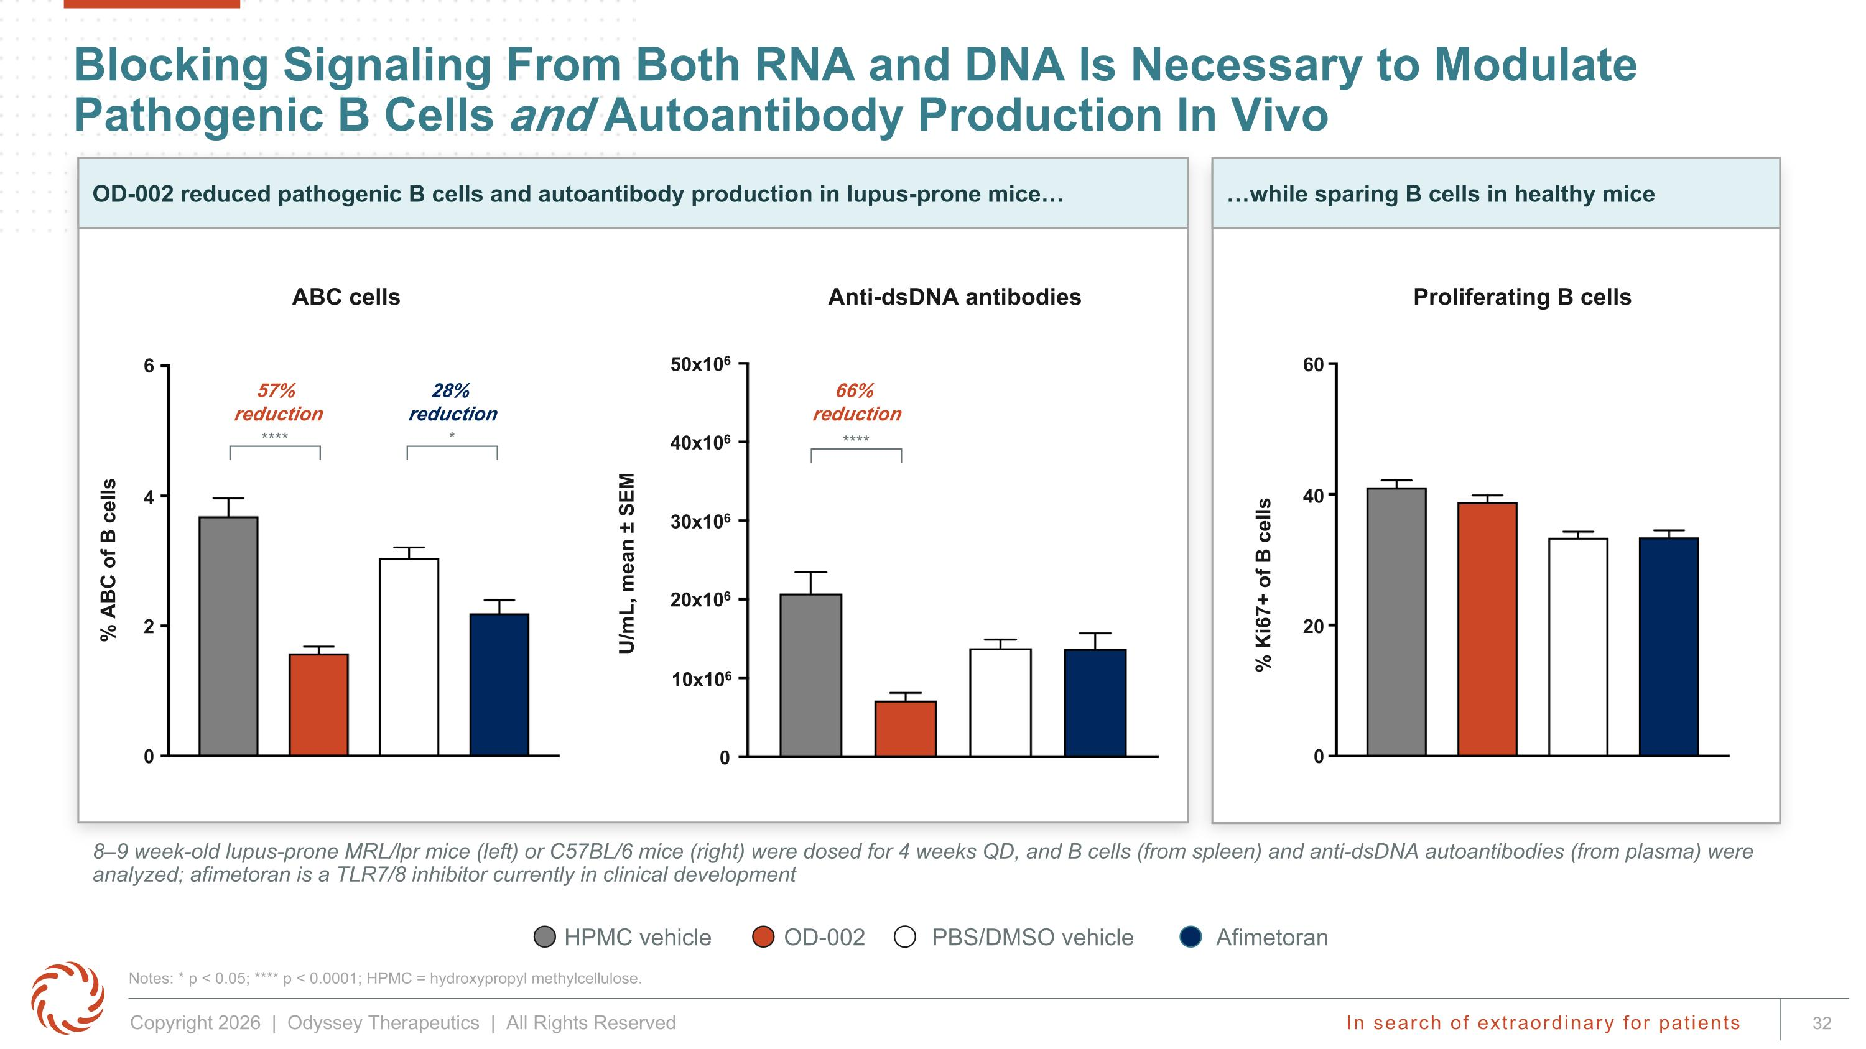
Anti-dsDNA antibodies while sparing B cells in healthy mice OD-002 reduced pathogenic B cells and autoantibody production in lupus-prone mice Blocking Signaling From Both RNA and DNA Is Necessary to Modulate Pathogenic B Cells and Autoantibody Production In Vivo Notes: * p < 0.05; **** p < 0.0001; HPMC = hydroxypropyl methylcellulose. 8–9 week-old lupus-prone MRL/lpr mice (left) or C57BL/6 mice (right) were dosed for 4 weeks QD, and B cells (from spleen) and anti-dsDNA autoantibodies (from plasma) were analyzed; afimetoran is a TLR7/8 inhibitor currently in clinical development % Ki67+ of B cells % ABC of B cells OD-002 HPMC vehicle Afimetoran PBS/DMSO vehicle ABC cells Proliferating B cells U/mL, mean ± SEM 50x106 40x106 30x106 20x106 10x106 0 60 40 20 0 6 4 2 0 66% ?reduction **** 57% ?reduction 28% ?reduction **** *

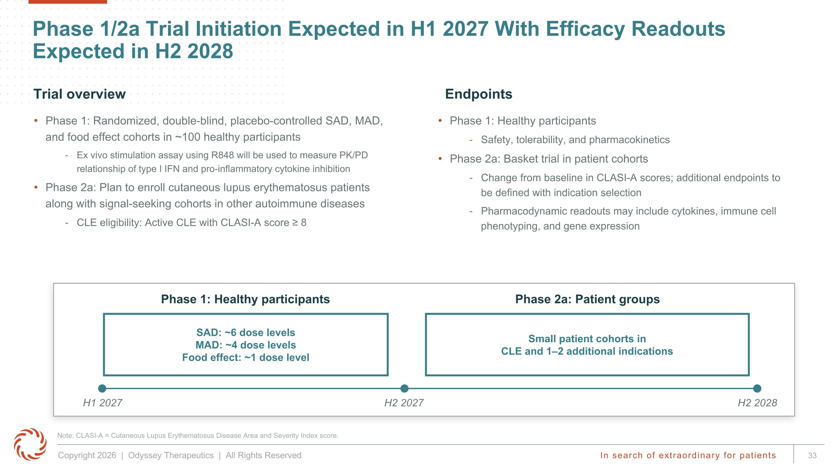
Phase 1/2a Trial Initiation Expected in H1 2027 With Efficacy Readouts Expected in H2 2028 Small patient cohorts in CLE and 1–2 additional indications SAD: ~6 dose levels MAD: ~4 dose levels Food effect: ~1 dose level H1 2027 H2 2027 H2 2028 Phase 2a: Patient groups Phase 1: Randomized, double-blind, placebo-controlled SAD, MAD, and food effect cohorts in ~100 healthy participants Ex vivo stimulation assay using R848 will be used to measure PK/PD relationship of type I IFN and pro-inflammatory cytokine inhibition Phase 2a: Plan to enroll cutaneous lupus erythematosus patients along with signal-seeking cohorts in other autoimmune diseases CLE eligibility: Active CLE with CLASI-A score ≥ 8 Phase 1: Healthy participants Safety, tolerability, and pharmacokinetics Phase 2a: Basket trial in patient cohorts Change from baseline in CLASI-A scores; additional endpoints to be defined with indication selection Pharmacodynamic readouts may include cytokines, immune cell phenotyping, and gene expression Endpoints Trial overview Phase 1: Healthy participants Note: CLASI-A = Cutaneous Lupus Erythematosus Disease Area and Severity Index score.

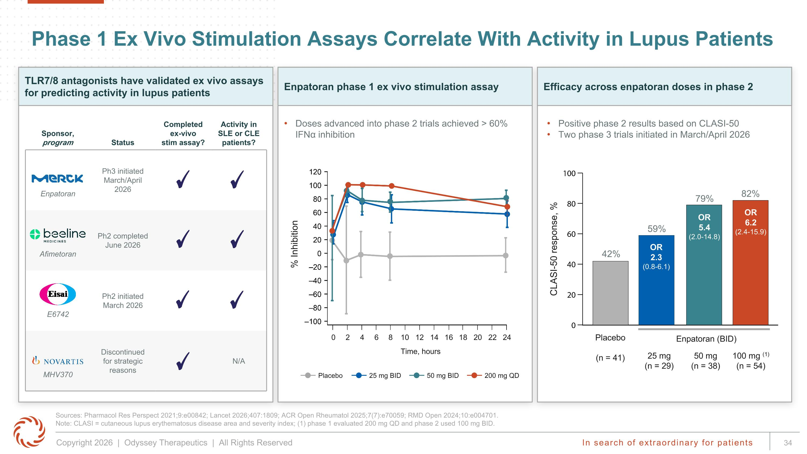
Doses advanced into phase 2 trials achieved > 60% IFNα inhibition Enpatoran phase 1 ex vivo stimulation assay Efficacy across enpatoran doses in phase 2 Sponsor, program Status Completed ex-vivo stim assay? Activity in SLE or CLE patients? Enpatoran Ph3 initiated March/April 2026 Afimetoran Ph2 completed June 2026 E6742 Ph2 initiated March 2026 MHV370 Discontinued for strategic reasons N/A Phase 1 Ex Vivo Stimulation Assays Correlate With Activity in Lupus Patients Sources: Pharmacol Res Perspect 2021;9:e00842; Lancet 2026;407:1809; ACR Open Rheumatol 2025;7(7):e70059; RMD Open 2024;10:e004701. Note: CLASI = cutaneous lupus erythematosus disease area and severity index; (1) phase 1 evaluated 200 mg QD and phase 2 used 100 mg BID. Positive phase 2 results based on CLASI-50 Two phase 3 trials initiated in March/April 2026 CLASI-50 response, % 42% Placebo (n = 41) 25 mg (n = 29) 50 mg (n = 38) 100 mg (1) (n = 54) 59% 79% 82% OR ?2.3 (0.8-6.1) OR?5.4?(2.0-14.8) OR?6.2?(2.4-15.9) % Inhibition 0 2 4 6 8 10 12 14 16 18 20 22 24 Time, hours Placebo 25 mg BID 50 mg BID 200 mg QD Enpatoran (BID) TLR7/8 antagonists have validated ex vivo assays for predicting activity in lupus patients

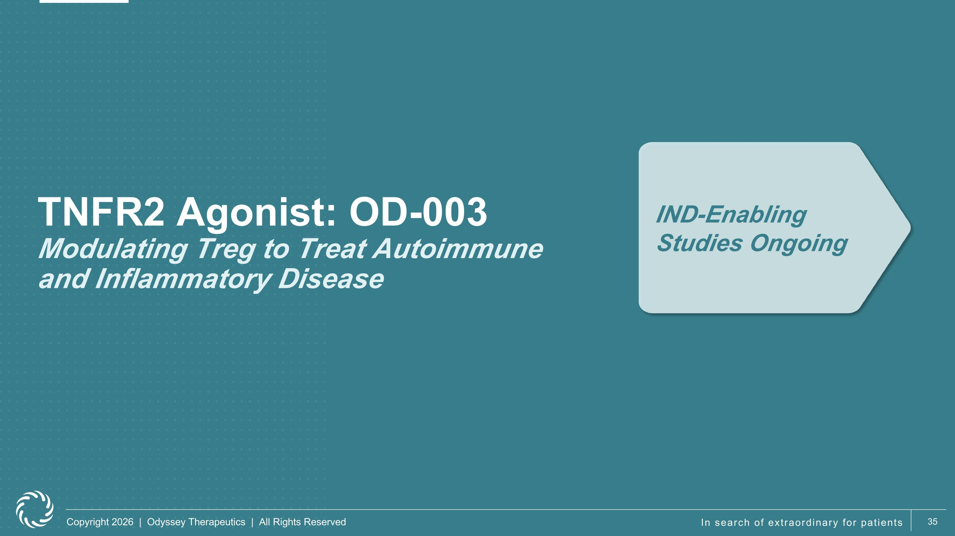
TNFR2 Agonist: OD-003?Modulating Treg to Treat Autoimmune ?and Inflammatory Disease IND-Enabling Studies Ongoing

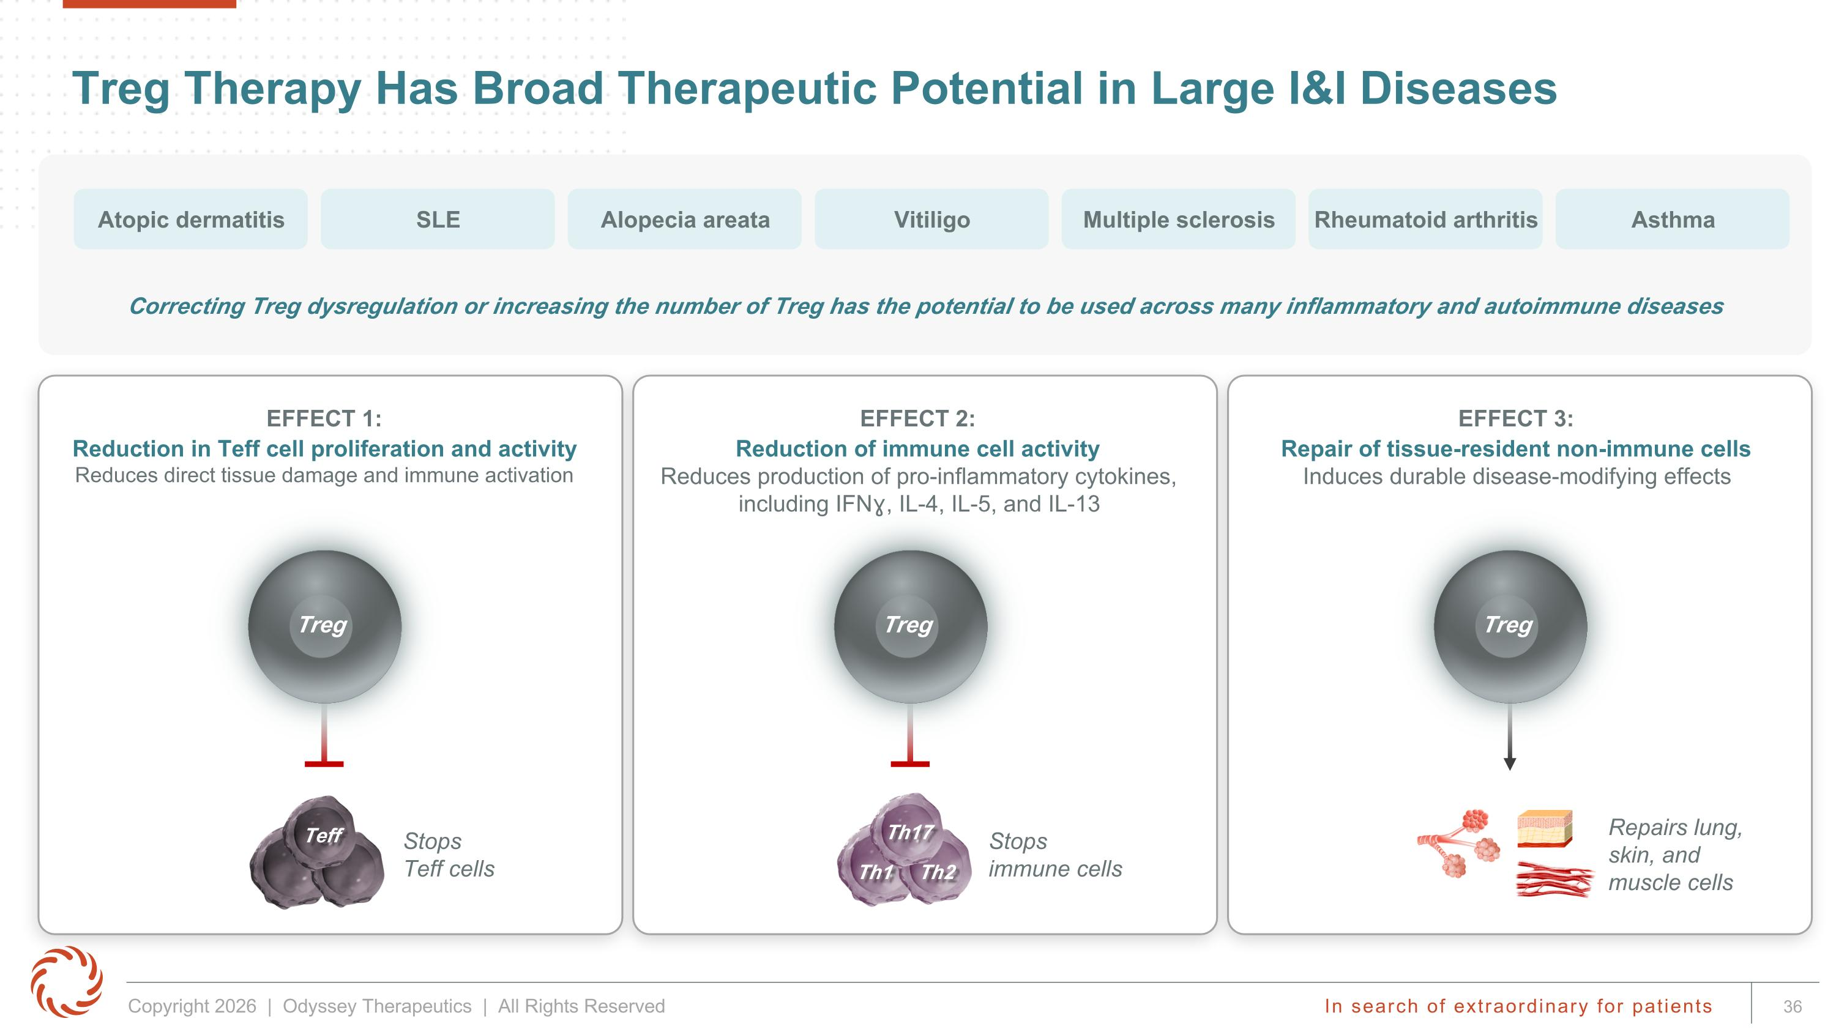
Treg Therapy Has Broad Therapeutic Potential in Large I&I Diseases Correcting Treg dysregulation or increasing the number of Treg has the potential to be used across many inflammatory and autoimmune diseases Atopic dermatitis SLE Alopecia areata Multiple sclerosis Rheumatoid arthritis Asthma EFFECT 1: Reduction in Teff cell proliferation and activity Reduces direct tissue damage and immune activation Stops ?Teff cells Treg EFFECT 2: Reduction of immune cell activity Reduces production of pro-inflammatory cytokines, including IFNɣ, IL-4, IL-5, and IL-13 EFFECT 3: Repair of tissue-resident non-immune cells Induces durable disease-modifying effects Stops immune cells Treg Repairs lung, skin, and muscle cells Treg Th17 Th1 Th2 Teff Vitiligo

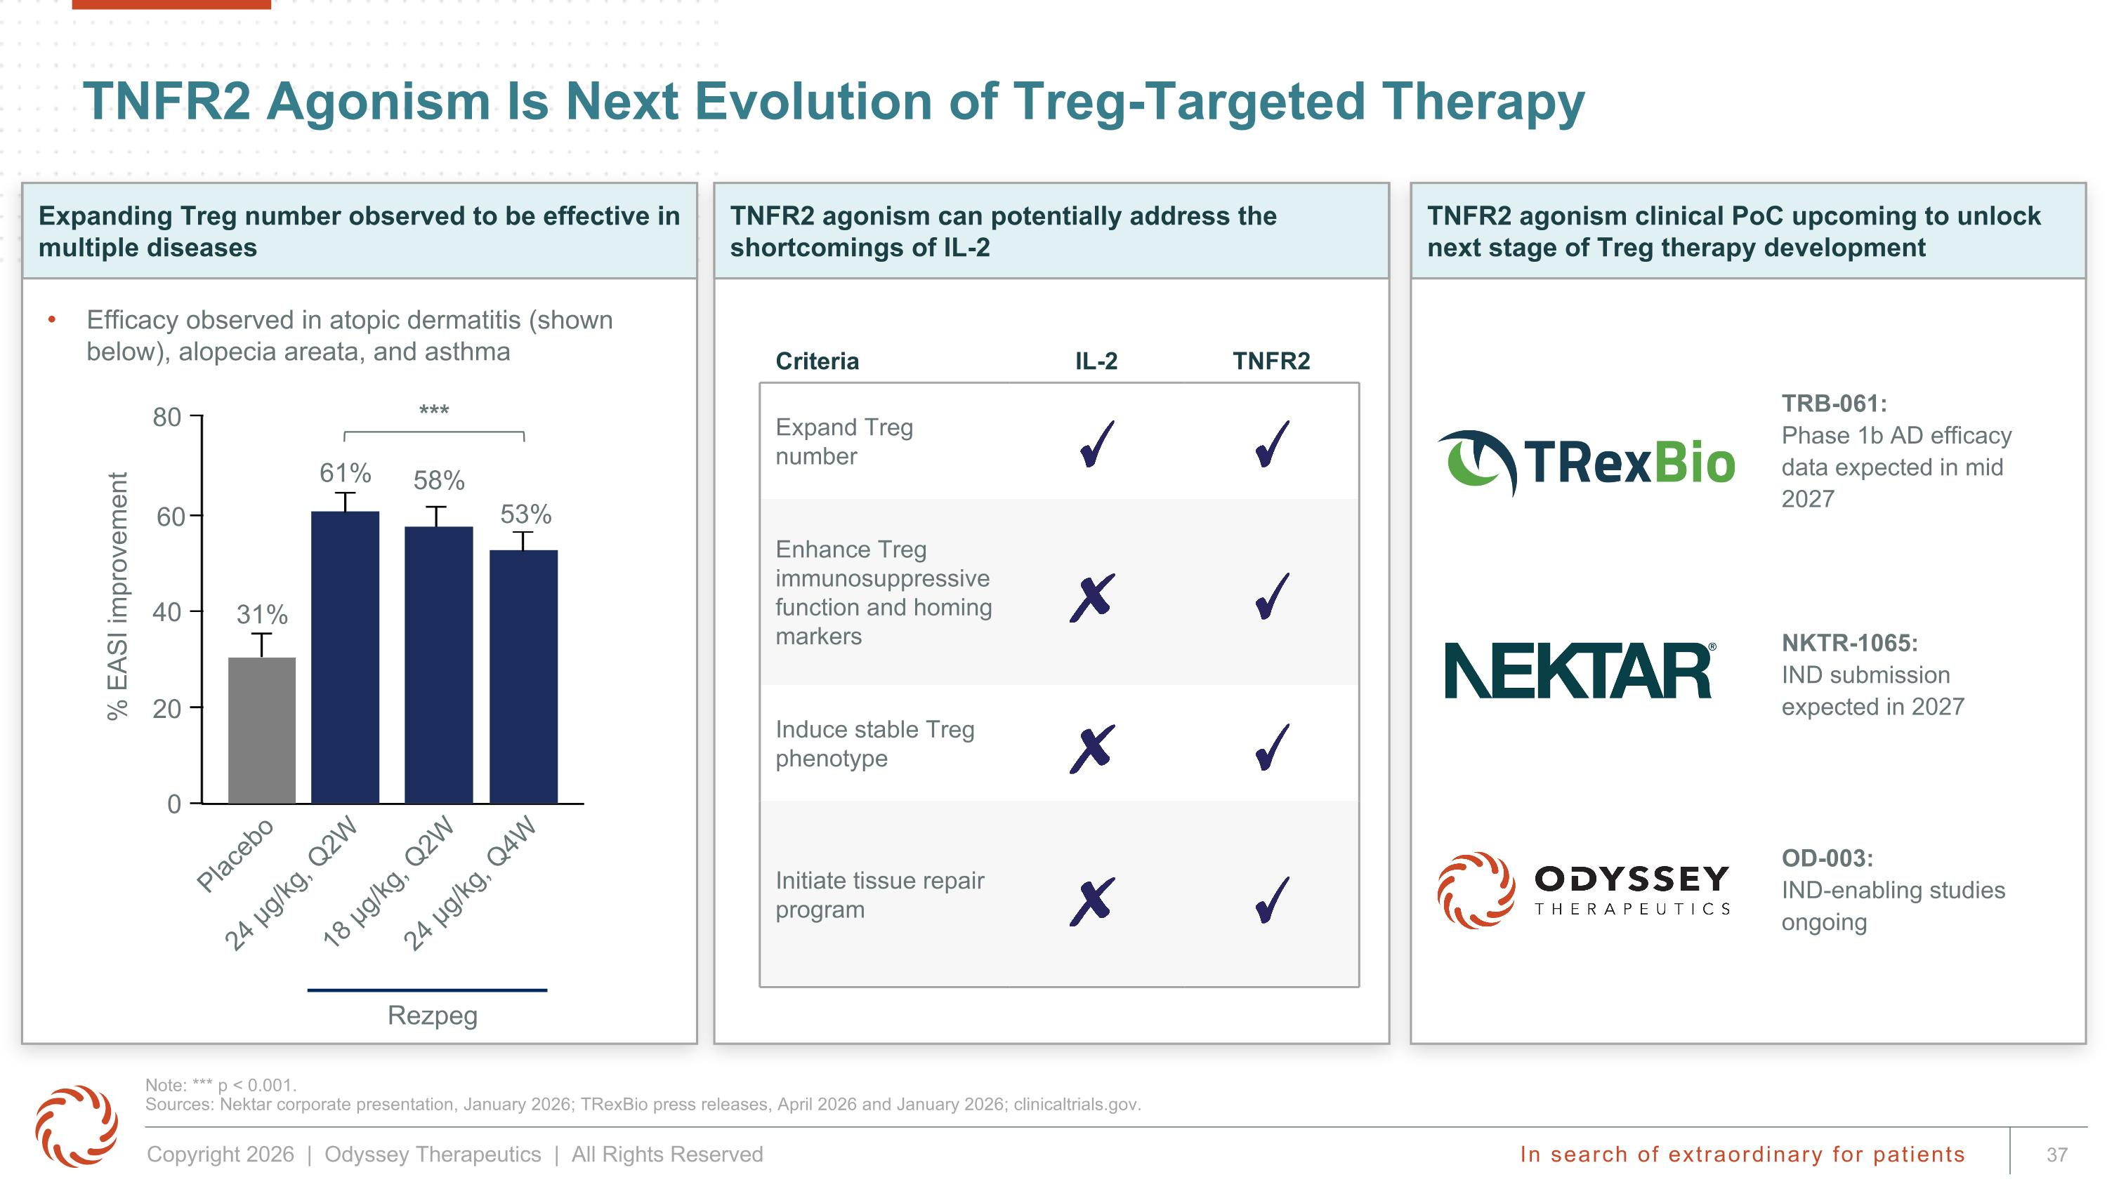
TNFR2 agonism clinical PoC upcoming to unlock next stage of Treg therapy development Expanding Treg number observed to be effective in multiple diseases TNFR2 agonism can potentially address the shortcomings of IL-2 TNFR2 Agonism Is Next Evolution of Treg-Targeted Therapy Note: *** p < 0.001.?Sources: Nektar corporate presentation, January 2026; TRexBio press releases, April 2026 and January 2026; clinicaltrials.gov. Criteria IL-2 TNFR2 Expand Treg number Enhance Treg immunosuppressive function and homing markers Induce stable Treg phenotype Initiate tissue repair program NKTR-1065: ?IND submission expected in 2027 OD-003: ?IND-enabling studies ongoing Efficacy observed in atopic dermatitis (shown below), alopecia areata, and asthma TRB-061: ?Phase 1b AD efficacy data expected in mid 2027 *** % EASI improvement 80 0 20 60 40 31% 61% 58% 53% Placebo 18 µg/kg, Q2W 24 µg/kg, Q4W 24 µg/kg, Q2W Rezpeg

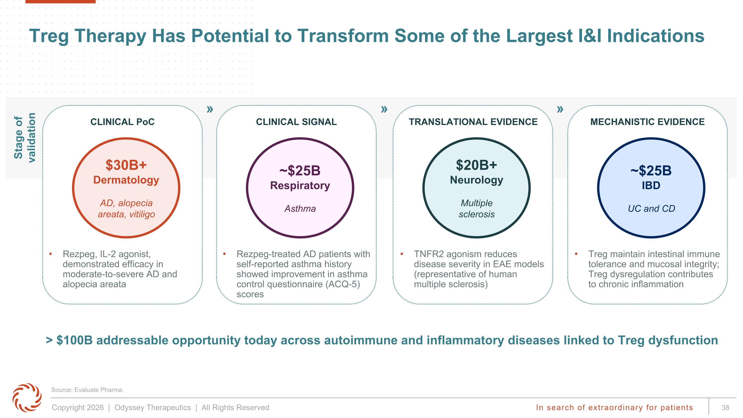
CLINICAL SIGNAL Rezpeg-treated AD patients with self-reported asthma history showed improvement in asthma control questionnaire (ACQ-5) scores ~$25B Respiratory Asthma MECHANISTIC EVIDENCE Treg maintain intestinal immune tolerance and mucosal integrity; Treg dysregulation contributes to chronic inflammation ~$25B IBD UC and CD Treg Therapy Has Potential to Transform Some of the Largest I&I Indications > $100B addressable opportunity today across autoimmune and inflammatory diseases linked to Treg dysfunction Stage of validation CLINICAL PoC Rezpeg, IL-2 agonist, demonstrated efficacy in moderate-to-severe AD and alopecia areata $30B+ Dermatology AD, alopecia areata, vitiligo TRANSLATIONAL EVIDENCE TNFR2 agonism reduces disease severity in EAE models (representative of human multiple sclerosis) $20B+ Neurology Multiple sclerosis » » » Source: Evaluate Pharma.

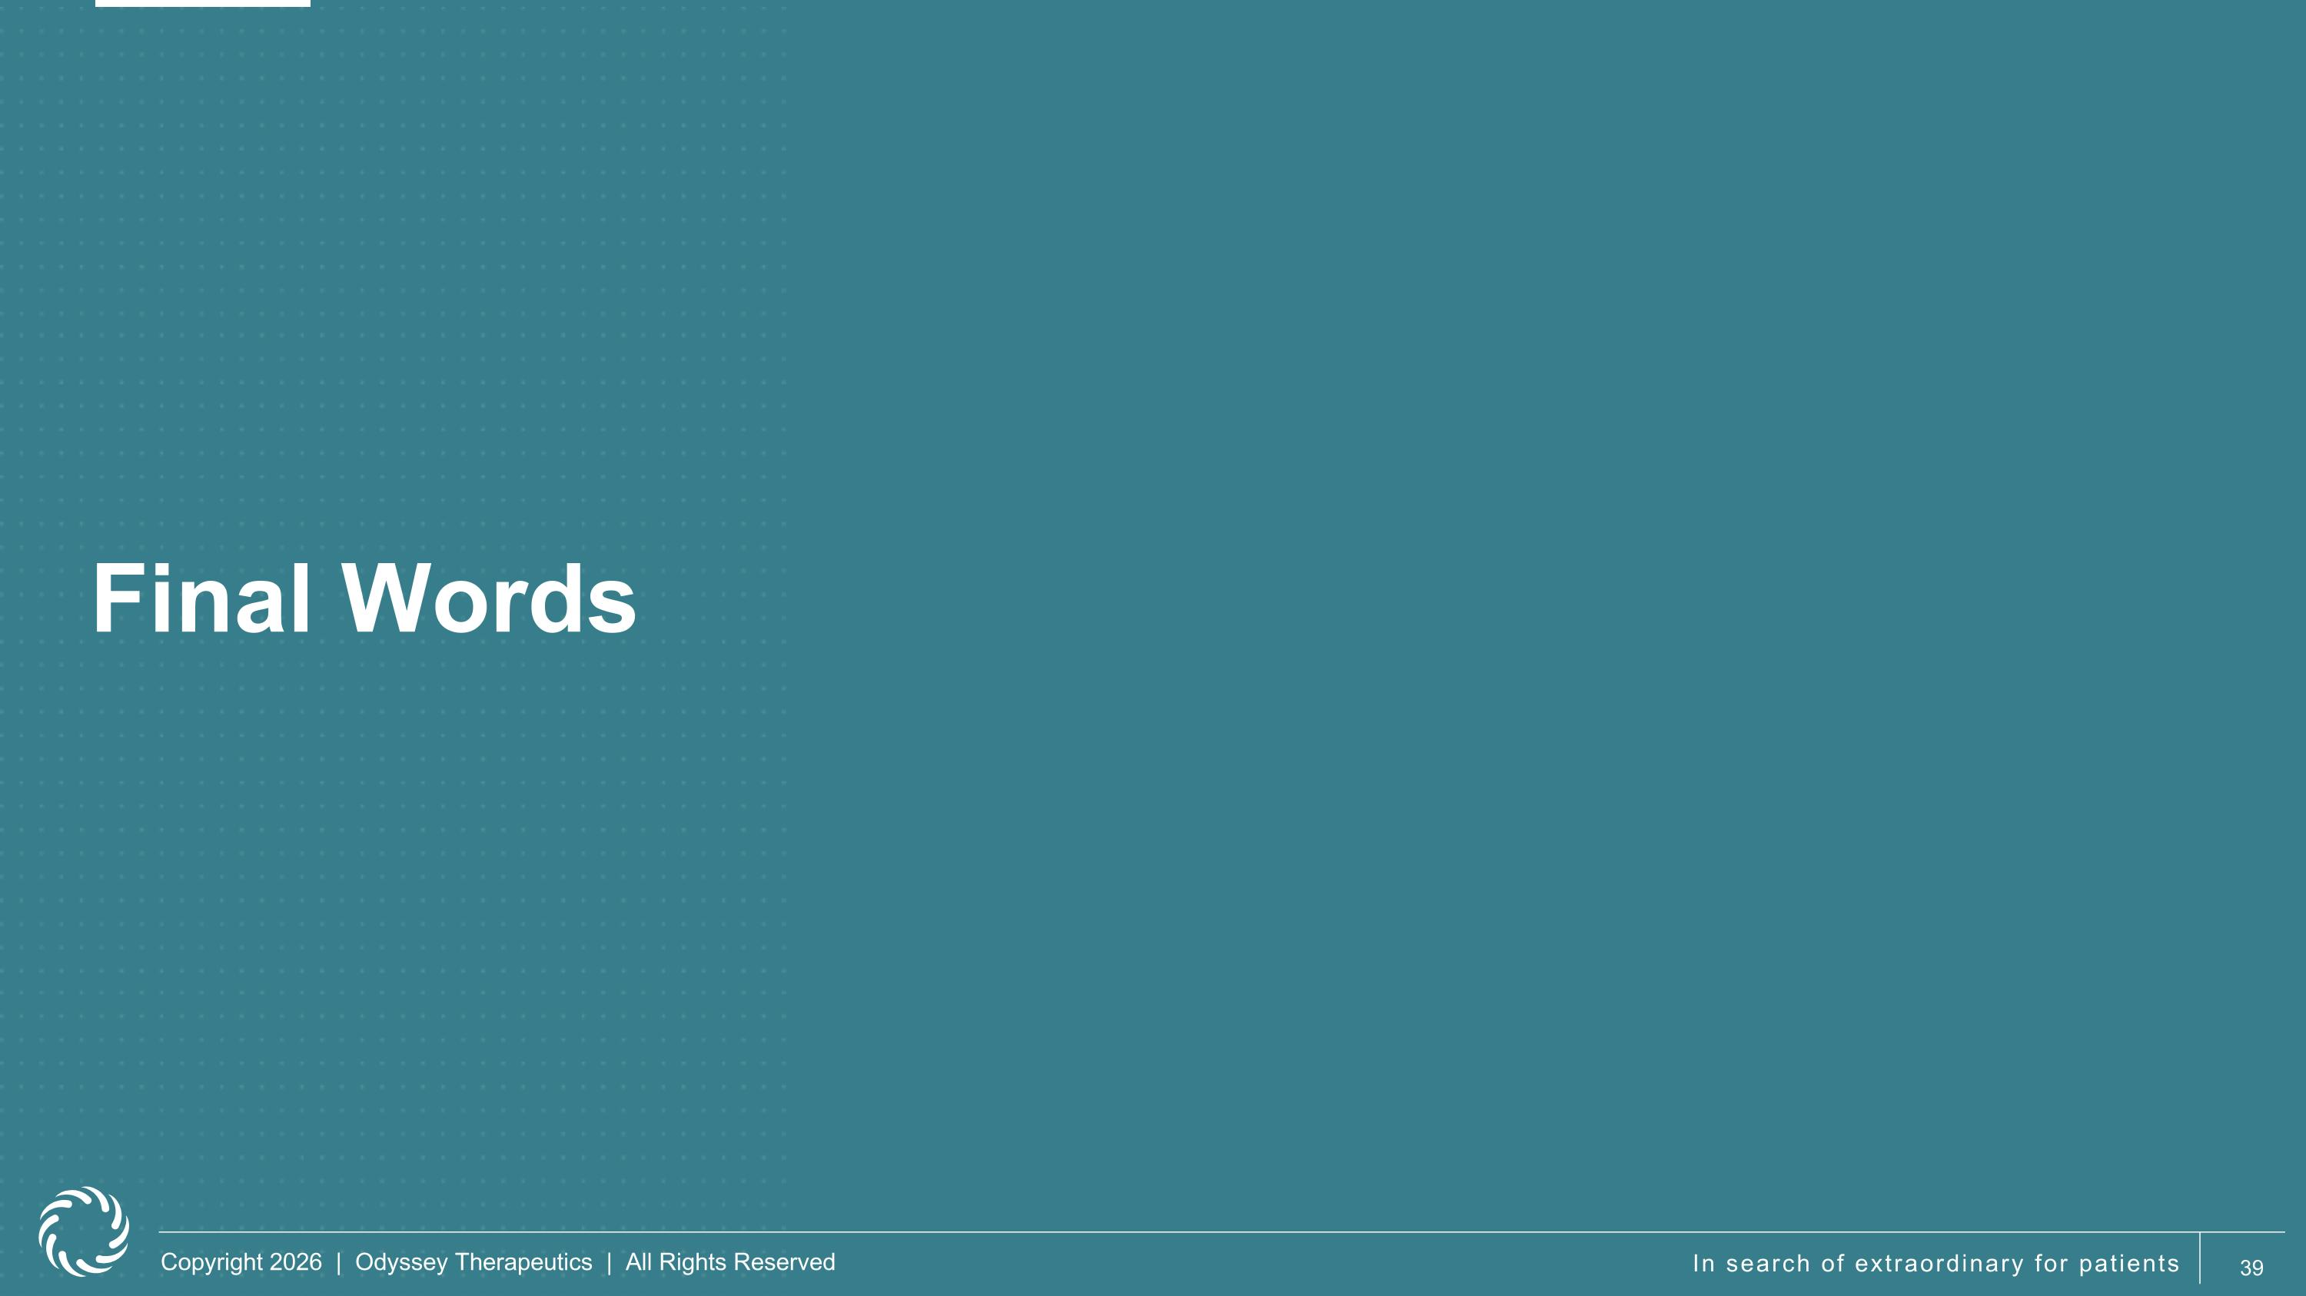
Final Words

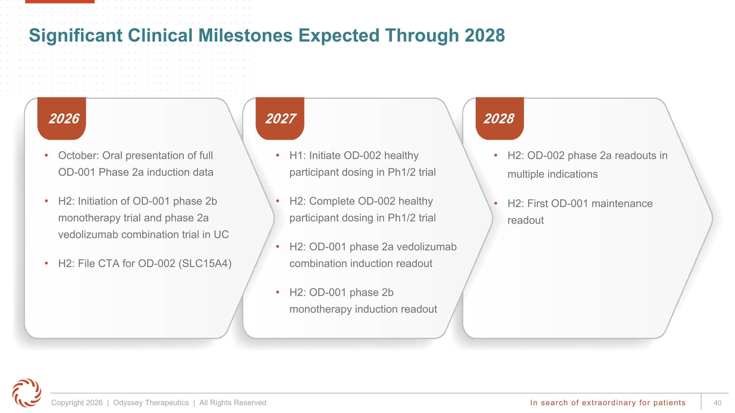
Significant Clinical Milestones Expected Through 2028 2026 2027 2028 H1: Initiate OD-002 healthy participant dosing in Ph1/2 trial H2: Complete OD-002 healthy participant dosing in Ph1/2 trial H2: OD-001 phase 2a vedolizumab combination induction readout H2: OD-001 phase 2b monotherapy induction readout H2: OD-002 phase 2a readouts in multiple indications H2: First OD-001 maintenance readout October: Oral presentation of full OD-001 Phase 2a induction data H2: Initiation of OD-001 phase 2b monotherapy trial and phase 2a vedolizumab combination trial in UC H2: File CTA for OD-002 (SLC15A4)



